Why Women got the vote in 1919
Information

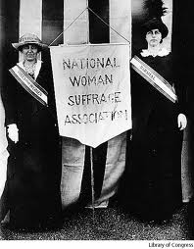
Suffragist campaigns had gradually gained momentum before the war. They gained support from across the social spectrum and included men as well as women. Suffragists were seen as rational group of women who would not break the law but try and get the vote through persuasion.

They had gained voting rights in local elections. This had been granted in the 1870s

There was a gradual widening of the franchise and a sense that it was only a matter of time. Men had had the vote since 1884 as long as there was a residency qualification but with many men losing their residency qualification due to serving in the army in France there was a realisation that the system had to change anyway and a chance to include women in the changes.
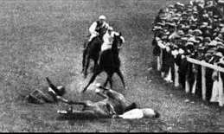
Suffragette campaigns kept the issue in the public eye. The problem with the Suffragists was that they could be ignored. Suffragettes solved this but by using such violent methods that they alienated as many people as they attracted.

At the start of the war both Suffragists and Suffragettes called of their campaigns. This was seen as the rational thing to do and removed many of the problems as both the government and Suffragettes had “painted themselves into a corner” and could not retreat from their position without loss of face.

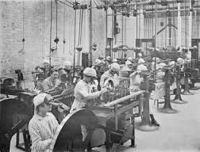
During the war women had taken over many of the jobs men had done. This was seen as significant and of great help to the country in its hour of need so the vote might be seen as a reward for doing the helpful and rational thing. Changes in work led to economic and social changes for women. This also gave women confidence in their ability and they were unlikely to forget these advances after the war.

Suffragists | Rational + | Easily ignored -
Suffragettes | Not rational - | Couldn’t be ignored +
World War One | Rational + | Couldn’t be ignored +

Explain the reasons why women gained the vote in 1919. 5

You must show a causal relationship between events.
1 mark can be given for each accurate, relevant reason and a second mark for reasons which are developed. Full marks can be achieved by providing five straightforward reasons, three developed reasons or a combination of both.

