Why did Women want the Vote

There were many arguments for women to be allowed to vote in parliamentary elections which evolved during the late 19th and early 20th century.
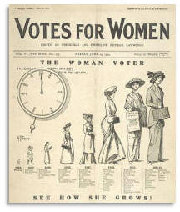
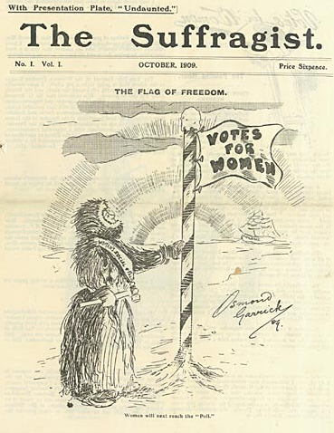
During the 19th century male voting had been based on owning property. It was argued that women owned property, and so should be entitled to vote. This argument was strengthened after the Married Women’s Property Act of 1882.

Women said that as they had to obey the same law as males, they should have similar rights in voting for these laws.

Women as well as men paid rates and taxes and therefore should have some say in how this money was spent.

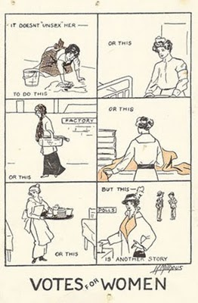
Women made a vital contribution to the nation’s economy by working and should be rewarded with the vote.
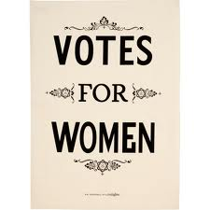
Throughout history women had been queens and if they were fit to head the country surely they fit to vote.

Women should have the vote to force parliament to pass laws which would benefit women.

Women drew attention to anomalies in the law which allowed uneducated males to vote when educated women could not.

Convicts and lunatics were not allowed to vote, many women did not like being compared to them.

After the 1884 Act many uneducated men in villages could vote while educated upper class women could not.

After the 1883 Corrupt Practices Act which stopped political parties from paying workers, women had an increasing role in parliamentary elections and were resentful of being trusted to work in the election while not being allowed to vote in it.

The role of women had been changing as the 19th century wore on. They had better educational opportunities, better rights to own property, they could be members of local councils, so why not nationally and many women of all classes were now in gainful employment. All this meant that women wanted equality and a chance to play a wider role in society

Women were also able to point out that women had the vote in other countries and this had not resulted in any weakening of their political structures.
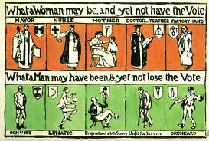
A famous poster of the time sums up many of the arguments against universal male suffrage at a time when no women had the vote.

Compare each pair and decide why it is unfair for that man to have the vote while the woman above him is not allowed to vote.

The first one shows a convict who may have broken the law of the local council while the woman above him is the mayor who controls that council. Thus the lawmaker cannot vote ever in national elections while the law breaker will be allowed to vote as soon as he is freed.
Mrs Pankhurst linked the ideas of the vote to the wider wishes of women when she said about the vote “First of all it is a symbol, secondly a safeguard and thirdly an instrument. Without the power to alter laws women would not improve their status in society, their education or on their employment”.

Arguments against women having the vote.

Although many women argued that they should be able to vote there were counter arguments that suggested reasons for them not to be allowed to vote.
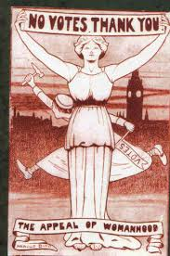
They were temperamental and prone to outbursts of emotion. As voting was a rational act they could not be trusted with the vote.

Some people thought that women too ‘pure’ or ‘delicate’ to know about politics and so should not be allowed to vote.

Some women themselves did not want to vote. Others said that women were not clever enough and if they could vote they would just vote as their husband or father told them.

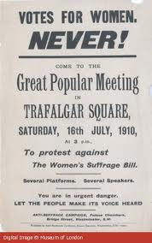
There were people who said that it was men who fought for their country in time of war therefore only men should be able to choose the government.
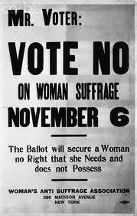
The attitude of men also made it difficult for women to progress. The twin spheres argument still held court in many places. Women were centred on marriage, child bearing and domestic affairs which made their minds’ trivial and emotional. If they got involved in politics it would overtax their brains and threaten the stability of the family and therefore society.

Politics was a corrupting business and if women got involved it would make them less feminine.

Their husband as the rational member of the family performed political functions on her behalf. Therefore she was represented already. Religion was still important in Britain and it placed women as subordinates.

There were fears from middle class ladies that a mass working class female vote would become a class rather than a gender issue.


