Urbanisation
Industrial Revolution: The effects of industrialisation and urbanisation.
Britain itself was changing more rapidly than at any time in its history. Its population was growing fast, and the lives of the people were changing as quickly.
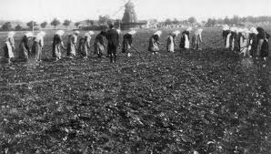
One of the biggest pressures was demographic change, particularly population distribution. Due to the improvement in agricultural methods and technology, the majority of the British public, who had previously lived in rural areas, were forced to move into cities in search of work as a result of the Agricultural Revolution. This vast movement of rural citizens led to urbanisation where most people lived in cities. They gained in some ways - more food, better clothing, more goods to buy. But they also suffered greatly in the filthy slums of the cities and in harsh treatment in factory work. This shift in the population also led to the decline in power of the landed aristocracy and an increasing influence of those who had made money from the factories in the new town’s and big cities.
Before the industrial revolution, power was firmly held by the landowners as Britain was a rural country. They could control the views of the people who lived and worked on their land.
J. Roebuck stated in “The making of Modern English Society” (1973) that The average man of the mid-19th century was much more likely to accept without question his inherited social rank and defer to his “betters” than his descendant a century later. A deeply rooted respect for rank and strong feelings of the obligations of authority were the basis for much of the social behaviour of the mid-19th century.

However, the industrial revolution changed all this and vast cities evolved where working class people lived in slum areas where the old landowners would not go, and the new factory owners lived in their suburbs. Benjamin Disraeli said the Queen Victoria ruled over two separate nations who never met; the rich and the poor.
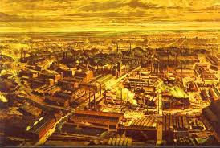
The new factory owners who lived in the suburbs started to argue that as they, rather than the landowners, were the new wealth creators in Britain, they should have a say in how this wealth was spent. These shifts in power suggested that they should be granted the vote and have an influence in who controlled the country. It was these wealthy middle classes claims that resulted in the passing of the 1832 and 1867 Reform Act.
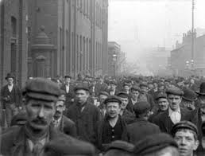
The industrial working class people started to get a consciousness of their class and interests. This was due to the fact that cities and factories housed large numbers of people who suffered terrible working and living conditions. This concentration of people in the towns and cities meant there was more chance of new political ideas spreading, especially with the railways and the development of national newspapers. As they lived in areas where their “betters” never went, there was no control over their ideas. They talked to each other about how they might organise to get better conditions in the factories where they worked and better living conditions in the slums. This led them to put pressure on parliament to get representation and a say in how the country was run. They had become a vital part of British society and couldn’t be ignored, in terms of suffrage, by those in power any longer. By the 1860s the skilled working class were vital to the success of Britain and as long as they were respectable, financially independent and no threat to the system they were safer inside the system rather than outside criticising.
All of these changes led reformers to argue that the British Parliament no longer represented the country properly. It was out of date and had to change, or be forced to do so.
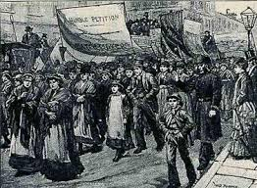
As pressure for greater democracy increased during the early part of the nineteenth century, many politicians favoured granting limited political reforms rather than risk a revolution. If more people were not enfranchised and given a political voice then they would have possibly embraced more revolutionary ideas. Therefore, a reason for the growth of democracy was to appease the threat of revolution from the working classes.

