Post War support for Unionism

During the War the main Scottish newspapers such as the Scotsman and Glasgow Herald had been Unionist and many local papers followed their example and dropped their support for the Liberal Party. The mainstream popular newspapers were all strongly pro-union. New papers formed during the War such as Glasgow Bulletin, launched in 1915 and Sunday Post, begun in 1914 were patriotic and continued this Unionist message after the war. Also some local Liberal newspapers in places like Dundee and Aberdeen had been taken over by their Unionist rivals and changed their editorial policy to match. This was backed up by the offer of money for local papers to get the Unionist message across.
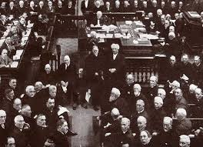
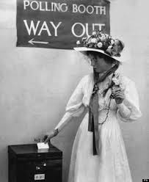
The Church of Scotland was very important at this time and there was a clear shift to the right and Unionist positions by their leadership. Protestantism played an important part in the party's working-class appeal projected through the endorsement and promotion of well-known Church of Scotland members, such as Eric Liddell. The Presbyterian churches attacked the ‘Irish menace’ and, since the bulk of Irish Catholics were Labour Party voters, the political impact was to encourage support for Unionism. The Scottish legal system also had strong links with the Conservatives.

The enfranchisement of women has also been seen as favourable to the Unionists and Conservatives as the women enfranchised in 1918 were over thirty, and tended to be reasonably well off. The Conservative Party were seen to be female friendly in terms of candidates and elected MPs. The first Scottish female MP was the Duchess of Atholl.

The Conservatives were one of the big political winners from the war. Their message of patriotism and the return to pre-war certainties was just what the electorate wanted to hear; the war had been ‘worth it’, but now life could get back to ‘normal’. There was desire for social changes after the horrors of the war but also a sense that the suffering was UK wide, not unique to Scotland so there was no great desire to break the union.

Support for Conservatives/Scottish Unionists was high particularly amongst the middle classes who saw their future as being part of union. The Scottish unionist/conservative party built up its working class support by emphasising the connection between the Union, the Empire, and the fate of local industry. The party’s promise of ‘unity across the classes’ was promoted as a reason to support Unionism.
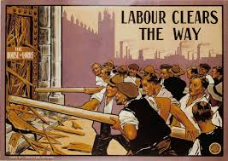
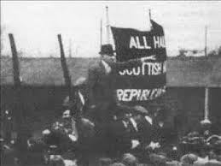
The Independent Labour Party was seen as a threat to the middle classes resulting in the Scottish Unionists achieving a majority of Scottish seats in 1924. Instances of radicalism after the war such as events of January 1919 in George Square led to some fears that the union would be forcibly broken up. The Conservative party was seen as the barrier to this and the more reliable party in resisting the socialist threat. There were also fears of ‘Bolshevism’ in Scotland fuelled by increase in communism led by John McLean and others. The Scottish unionists/ conservatives were seen as the barrier against the ‘red menace’ which threatened the ‘British’ way of life.
The war undermined Scottish Liberalism. The Liberals were the big losers from the war. Though many had opposed the war in 1914 however as the party of government they had taken the decision to go to war and faced blame for the handling of it. As the Labour Party was seen as being risky, many voters switched to the Conservatives as the safe option.

The war years showed that support for Scottish Home Rule continued but post war patriotic support for UK union left little room for nationalist sympathies or support.
Economic troubles in the 1920s saw Scotland suffering more than many parts of England due to her reliance on old industries. Despair and hopelessness as the economy crashed in 1920 following the collapse of the short-term restocking boom and employment insecurity in the cities – periodic slumps due to the trade cycle. But this did not lead to desire to break the union.

Source E: from Ewen A. Cameron, Impaled Upon a Thistle: Scotland Since 1880 (2010).

Broad movements in Scottish political culture favoured the Unionists. Both the Glasgow Herald and the Scotsman were Unionist and many local newspapers had also abandoned Liberalism. The Unionists even considered giving financial support to local newspapers to bolster the party’s message. More important was the shift to the political right by the Presbyterian Church leadership in the 1920s. This is clear in attitudes towards the first Labour Government, the General Strike and the expression of racist views towards Scotland’s Irish community. The enfranchisement of women has also been seen as favourable to the Conservatives. The women enfranchised in 1918 were older, over thirty, and reasonably well off. Conservatives paid a great deal of attention to wooing this group and were much more fearful of the equal franchise of 1928 with its inclusion of younger, unmarried women in the electorate.

How fully does Source E explain the strength of support for unionism in Scotland?
Use the source and recalled knowledge. 9

