The Scottish Martial traditions and the Kilted Regiments

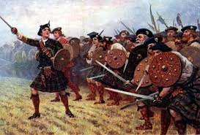
Much of the story of Scotland’s martial traditions comes from the times before the Battle of Culloden in 1746. The Highland Clans were set up on feudal lines as a military organisation. About half of the people in Scotland lived in the Highlands and as the land was poor and there was no alternative work, the clans would raid into the South of Scotland and even England on occasion to provide for themselves. They became known as fierce fighters and were very much feared. After the Jacobite invasion of England in 1745, which terrified the government and people, they were finally defeated at Culloden, near Inverness. The Government decided to break the Clan system and banned Highlanders from wearing kilts, playing bagpipes and carrying weapons.

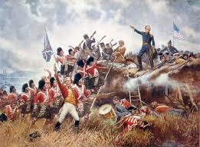
There was one way Highlanders could circumvent these bans and that was by joining the British Army. This was at a time that Britain was expanding its Empire and Scots regiments became central in conquering India (Battle of Plessey, 1757), Canada, (Heights of Abraham, 1759) as well as many of the African colonial wars. The Battle of Waterloo had Scottish Soldiers from Lowlands and Highlands fighting together as happened in the Crimean war. The Highland Scot had changed in a hundred years from the kilt wearing savage, terrifying peaceful British citizens to the loyal shock troops of the Empire. By 1800 there were 20 Highland Regiments and although the number of regiments fell with amalgamations the number of troops needed did not.
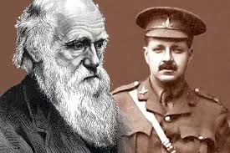
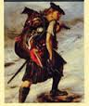
The ideas of Charles Darwin suggested that survival of the fittest was the way the world worked and that certain races held certain characteristics. The belief of the time was that Scots were aggressive loyal fighters who could be best harnessed for the Empire by making them soldiers.

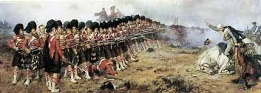
The writings of Walter Scott popularised the romantic idea of the loyal Highland warrior and Queen Victoria’s preoccupation with the Highlands gave the area and its people a higher and more positive profile than previously. In fact the “invention” of tartan, as worn in modern kilts dates from early 19th century, although it has been assumed into antiquity to back up the traditions of the army. The power of tartan can be judged by the fact that the War Office ordered Lowland regiments to wear tartan trews from 1881.

When the war broke out in 1914, Scottish recruiting concentrated on the picture of the heroic Highland Warrior, thereby putting pressure on young men not to let down their ancestors. This was helped in Scotland because the Regiments were very much local regiments with each regiment and battalion recruiting from its own local area.

This resulted in a proportionately higher number of Scots joining up than in the rest of the UK. As a result of this more Scots died per capita than anywhere else in the war apart from Serbia and Turkey. When it is realised that many of the Serbs and Turks died from disease while most Scots were killed in action it shows how 26% of Scotland’s young men became casualties, as opposed to 11% for the rest of the British Army.

Practice Question

Source A is about the recruiting campaign to the armed forces in 1914.
Source A
At first the outbreak of war was exciting. The opportunity to go on an adventure with your pals in a kilted uniform was too good to miss. There were more Scots volunteers in proportion to the size of population than any other area of the UK. The possibilities of facing serious injury or death were put aside. War hysteria also played a part. The War Propaganda Bureau told stories of Belgian babies being bayoneted and nurses and nuns being raped by German soldiers.
How fully does Source A explain why so many Scots volunteered for the armed forces in 1914? 6

