The Role of Middle and Working Class Women in the 19th Century

The idea about men and women in the 19th century was that they almost different species who lived in separate spheres. Men were rational and lived in the public sphere where they worked and provided for the family. Their women stayed at home and looked pretty. They looked after the home and were emotional creatures. As a result of this men controlled the lives of women, thinking for them and indeed not letting them think for themselves. A song of the time explains this well – “She’s only a bird in a gilded cage, a beautiful sight to see’. Her cage of married life may be gilded – but it is still a cage.

In Victorian times, many people thought that middle class women were far too frail and delicate to do anything except look after their children and their homes. In their spare time they played the piano or did embroidery. They had little freedom and often had to do as their fathers or husbands told them. They had no rights to their own money or property. No one thought that a ‘lady’ should be educated or have a career and they were not allowed any say in how the country was run. In short their only ambition was to make a good marriage and then their life would be complete. Once they had made this marriage they, and everything they brought to the marriage, became the property of her husband In order to make such a marriage they had to look the way men wanted them to look, behave decorously, never argue and be accomplished rather than educated.
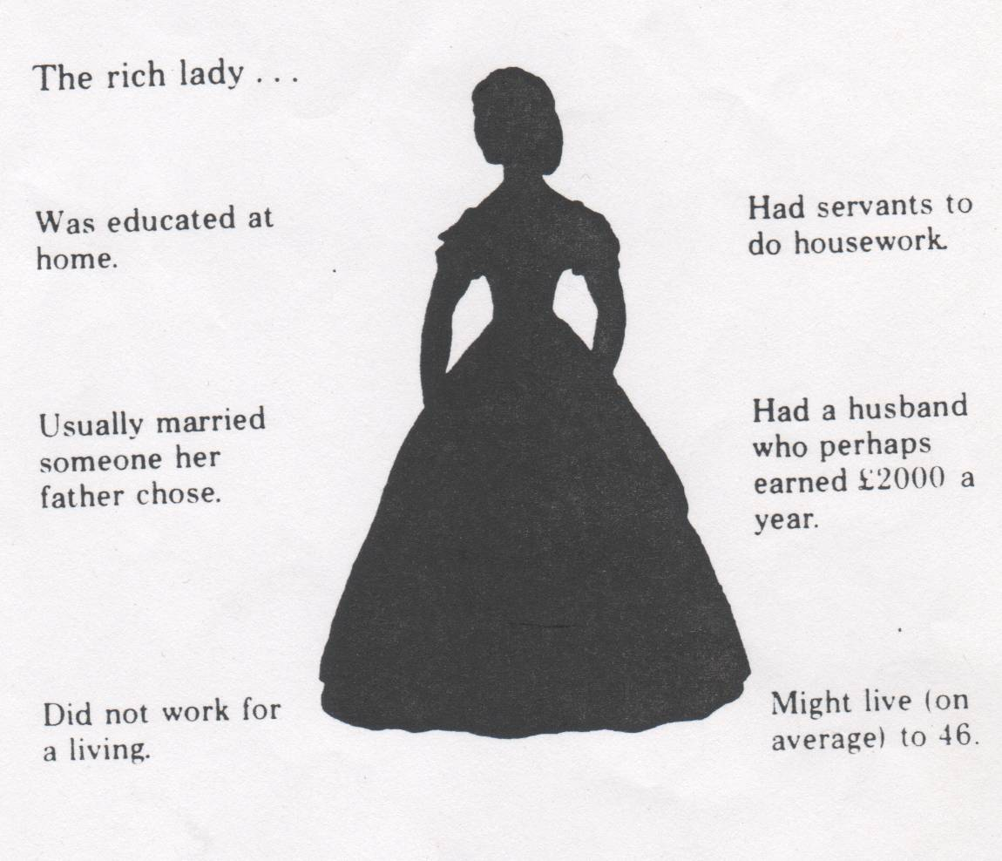
Source A written by a man.
“an exquisite slave, a humble, a flattering , tea making, piano playing being, who laughs at our jokes, coaxes us and fondly lies to us throughout our lives.”

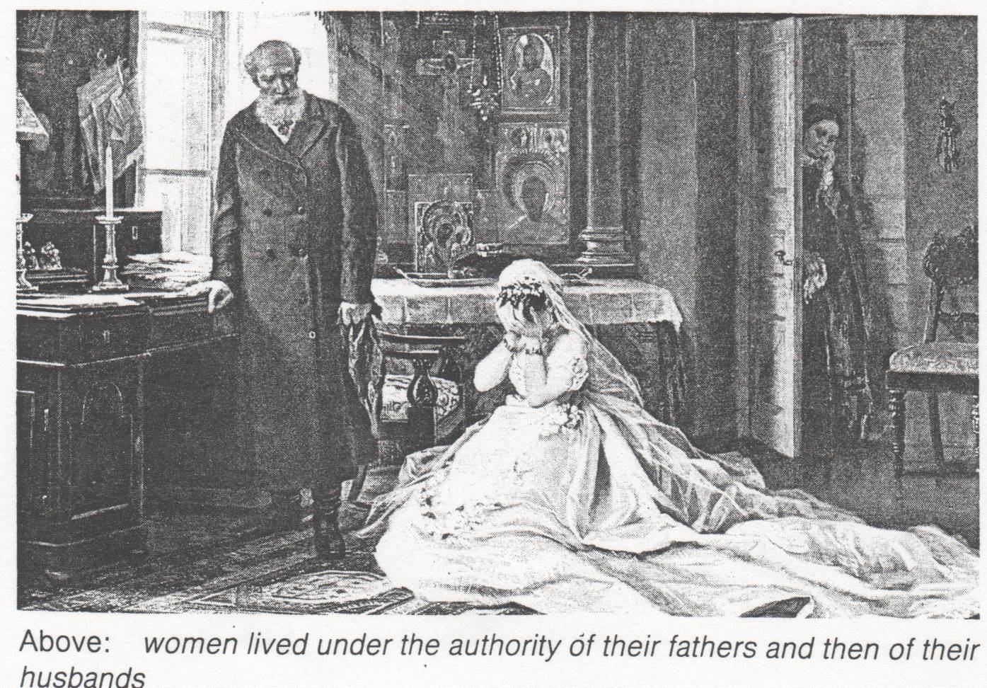
Source B by a woman.
“I feel like a dummy that does what it is told as the strings are pulled.
We are kept in ignorance and told nothing of life, of sex. All we do is wear expensive gowns, look delightfully bored and majestically useless. I seek employment and independence”.

Some views of women in the 19th century
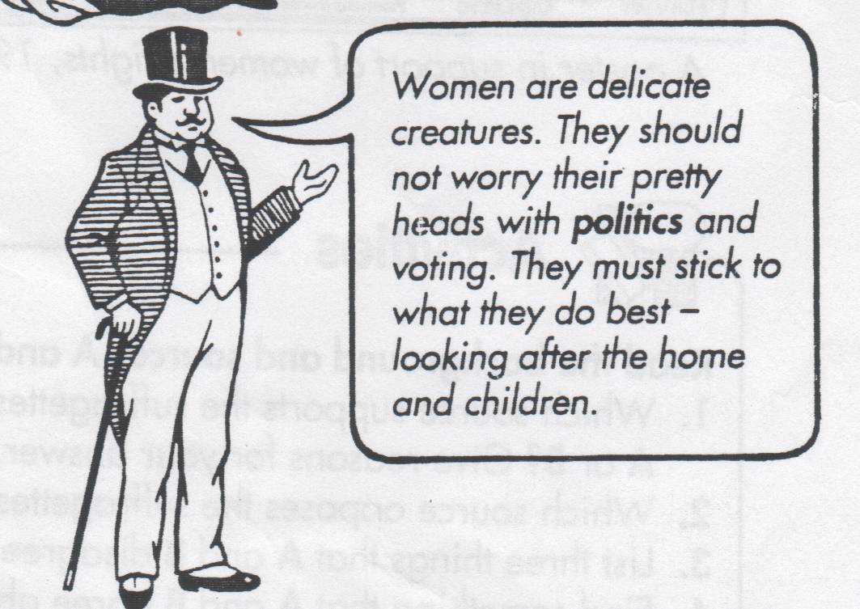
The average woman is inferior to the average man.
It’s a man’s place to rule and a woman’s to yield.
The man is head of the house.
A woman’s place is in the home.
Women are helpmates for men.
Ladies are merely children of a larger growth.
A husband is entitled to beat his wife in order to make her obedient.
If a husband and wife separate the law is on his side.
The woman only has limited rights to see her children.

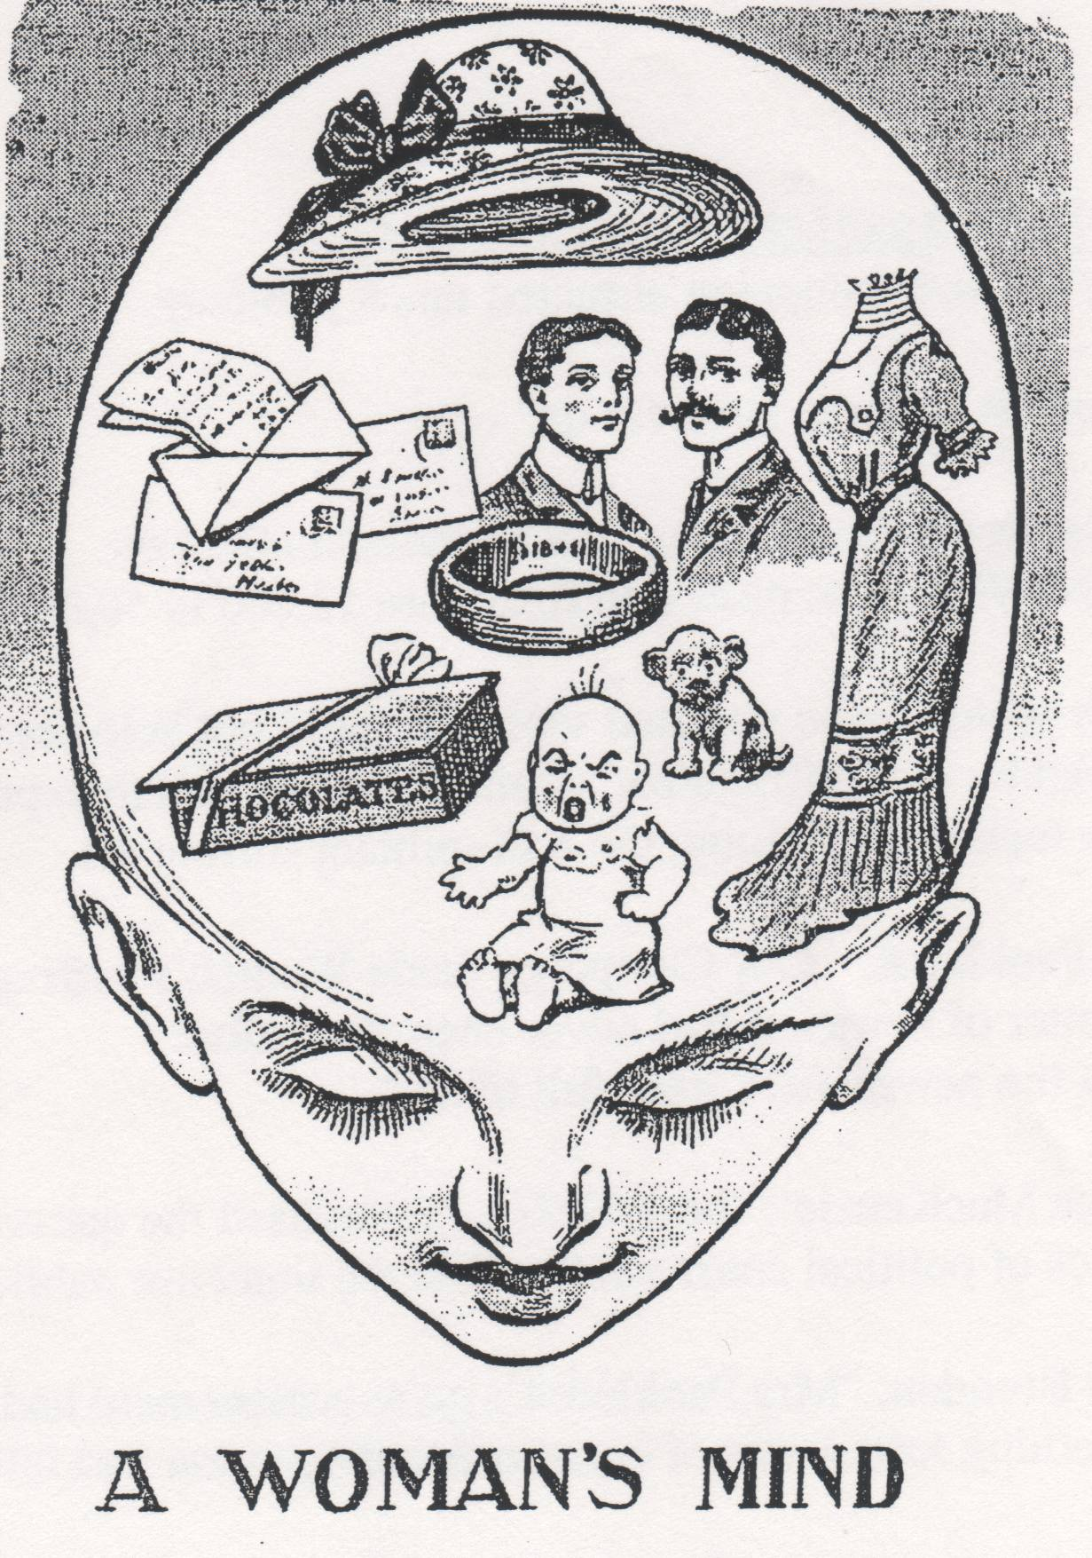
Here is an extract from a book written by Mrs. Gwen Reverat in which she recalls the life of her aunt.

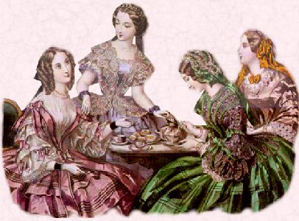
Ladies were ladies in these days, they did not do things themselves, they told other people what to do and how to do it. Aunt Etty was such a person. She told me when she was 86, that she had never made a pot of tea in her life, and that she had never in all her life been out in the dark alone, and I don’t believe that she had ever travelled by train without a maid. She always took her maid with her when she went in a carriage to the dentist. I am sure she had never sewed on a button and hardly ever posted a letter herself. Once she wrote when her maid was away for a day or two, “I am very busy answering my own door bell”. But of course when Janet was away the housemaid was doing all the real work; Aunt Etty was only perhaps finding the postage stamps for herself or putting on her own shawl – the sort of thing she rang for Janet to do every five minutes all day long.

For middle class women there were too many hours in the day.

The experience of the working class woman was totally different. They usually did not have a choice about whether they went to work. It was essential for them to find a job in order to provide basic food and clothing for their families. Most of these women worked in factories or in domestic service as maids or cooks.
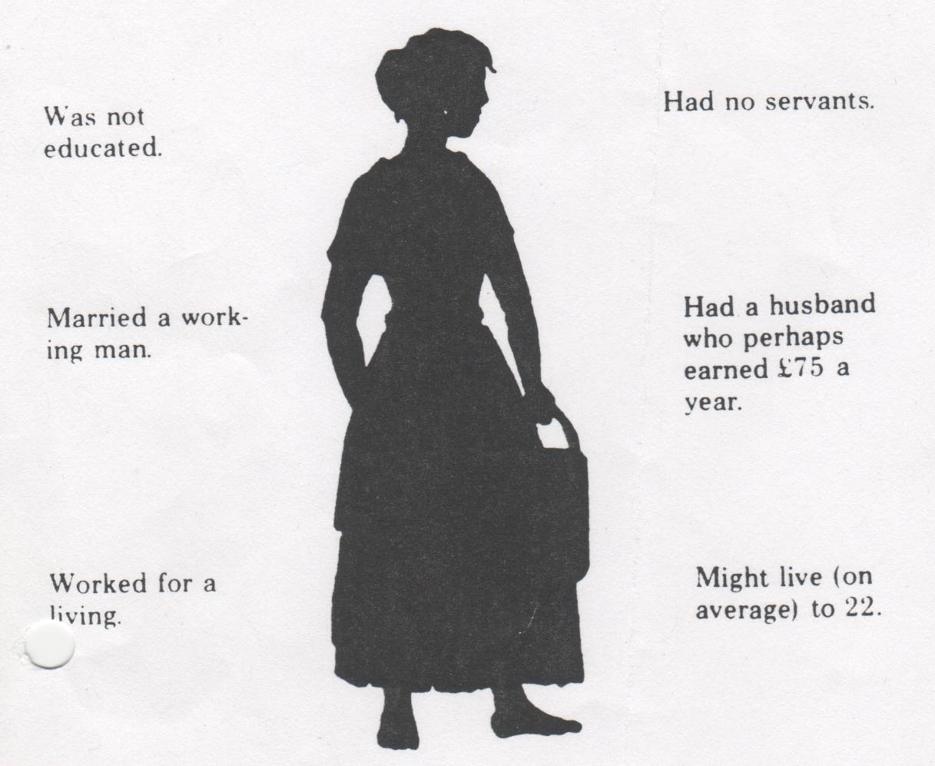

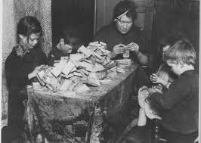
A large number of them also worked in ‘sweated trades’. This meant working from home or in cramped workshops making things like matchboxes, candles or hats.
Other workers, called seamstresses, worked at home and got one penny an hour for making shirts. Some could not afford candles and sewed by the light of street lamps. “I cannot earn more than 4s 6d to 5s per week – let me sit from eight in the morning till ten every night; and out of that I shall have to pay 1s 6d for trimmings, and 6d for candles every week; so altogether I earn about 3s in the six days.”

No matter where they worked, hours were long, the pay low and conditions harsh.

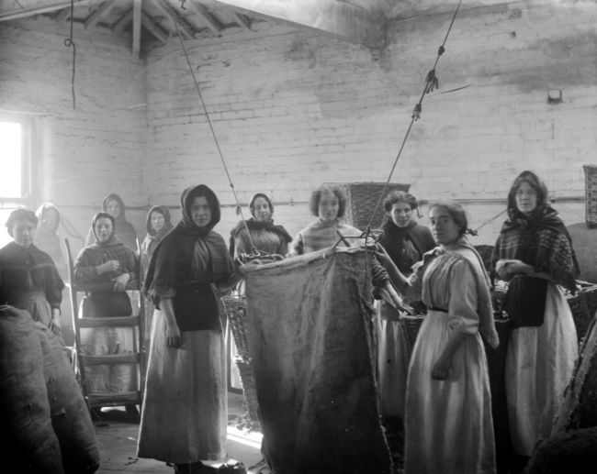
For these working class women, life was a terrible existence, working long hours in dangerous and unhealthy conditions in mills and factories where they exploited by the owners making them work for long hours with low pay to maximize profits, without thinking about their welfare or rights.
“Fourteen and a half hours on our feet! Mary suffered so much from her feet we had to cut her boots off. Ruby was off work due to an illness caused by standing too long but when the doctor told her not to go back to work she said “I must go back – what else can I do”.

Most of the women had large numbers of children, eight or nine not being uncommon. They also had to work for their family and look after the house after they had done a day’s work of twelve to fourteen hours. Many were beaten up by drunken husbands.

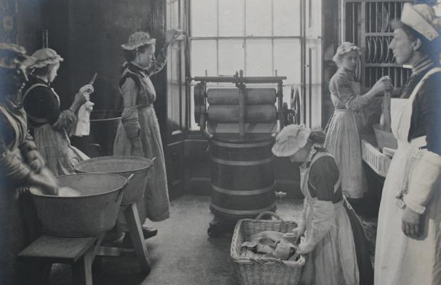
Many women worked as domestic servants, in large houses owned by rich people. There were no labour saving devices to help take the drudgery out of work until the late 19th or early 20th century. Domestic servants usually worked 12 to 14 hours a day. Many were housed in cold, cramped attics. They were fed on left overs and only allowed half a day off once a fortnight.

A typical day for a working class woman could be as follows.
Margaret Llewelyn Davies remembers

“I had to get up by four in the morning and get my baby out of bed, wash and dress it and then leave home by five as I had half an hour’s walk to take my baby to my mother’s and then go to my work and stand all day till half past five at night and then walk home again with my baby.”
Another women remembers her mother working

“Mother used to leave for her night work at six in the evening. She left me to put the kids to bed and to take the baby to the minder’s before I went to school. Most kids had to do the shopping in the morning before school. If you didn’t do it, you didn’t get your dinner.”
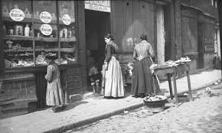

For working class women there were too few hour in the day.

