The Crisis in Scottish Identity post 1918?

In the 1920s all three major parties actively supported the union and there was a revived support for Conservative/ Unionist Party. The Conservatives and Liberals gave no support to Scottish Home Rule and Home Rule bills went nowhere as there was no Post war patriotic support for Home Rule which left little room for nationalist sympathies or support. The Middle classes still saw future as being part of union and part of the British way of life.

This support for conservatives/unionists was not caused only by crisis of Scottish identity. The main stream popular newspapers all strongly pro-union and it was also based on the collapse of the Liberal Party across UK, radicalization of working classes in Scotland, and the growth of ILP/Labour Party. The Conservatives seen as barrier against ‘red menace’ that was claimed to threaten the whole country.

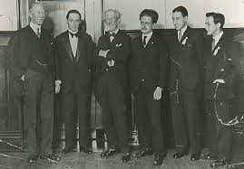
Lack of popular support for Labour Party's election manifesto promise to fight for restoration of the land of Scotland to the Scottish people, and they were not popular in the early 1920s.

However, there was increasing support in some areas for nationalism – National Party of Scotland established in 1928, leaders McCormick and Muirhead but they gained little support and its leaders gained less than 5% of the vote in each constituency.

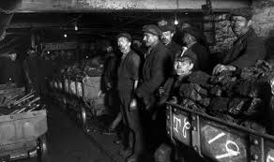
Economic troubles in 1920s saw Scotland suffering more than many parts of England. There was a heavy reliance on old industries, the products that had made Scotland the workshop of the Empire.
During the war Dundee’s jute industry boomed as demand for sack cloth rose but after the war the industry faced direct competition from Calcutta in world markets. Price of goods collapsed resulting in mass unemployment, deep social misery and discontent especially in Dundee and several firms went into liquidation.
Demand for steel increased during the war as it was needed for the shipbuilding industry. But other countries increased their steel making during the war years and Scots manufacturers could not compete. As a result the iron and steel industries were severely
affected by the downturn in demand from 1921 onwards.
This was repeated with shipbuilding. After the war a return to competitive tendering along with the decline in the demand for steel and for ships, foreign competition, labour disputes and a shortage of manpower and materials all led to problems and shipbuilding went into decline.

The Scottish Renaissance also had a profound effect on the Scottish independence movement, and the roots of the Scottish National Party may be said to be firmly in it. However in 1920s there was very little national support for separation.
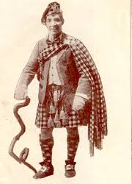
Scottish culture and Scottish identity was seen by some as being eroded by the spread of Englishness in all aspects of life. In UK terms Scottish identity became reduced to quaint tartan clad music hall routines such as Harry Lauder. There was some influence from the Scottish Literary Renaissance artists in creating and reviving sense of identity but only in small artistic areas. Some artists reflected lamenting the end of old Scottish way of life with books such as Lewis Grassick Gibbon’s ‘Sunset Song’.

Source A: from ‘Scotland and the Impact of the Great War’ by John A Kerr.

In 1918 the Labour Party's election manifesto promised to fight for the complete restoration of the land of Scotland to the Scottish people but these proposals did not catch the public's imagination or support. In the 1920s all three major parties actively supported the union and Home Rule bills in parliament in 1924 and 1927 went nowhere.
Nevertheless there were some who continued to campaign actively for an independent Scotland and in the 1920s economic distress made more people listen to the arguments for independence.
Radical nationalists wanted to resist the erosion of Scottish culture and Scottish identity by the spread of Englishness in all aspects of life. Artists, writers and poet, such as Hugh MacDiarmid, styled themselves as a Scottish literary renaissance and took pride in their attacks on those who, in their view, had sold out to England.
In May 1928 in the National Party of Scotland was founded but its leaders, Roland Muirhead and John McCormick, received only 3000 votes in the 1929 general election, less than 5% of the vote in each constituency.

How fully does Source A illustrate the crisis in Scottish identity that developed after 1918?
Use the source and recalled knowledge. 9

