The Changing Role of Women

Women’s contribution to the war
Work in Civilian jobs
In 1911 it is calculated that fewer than 6000 women were employed in the heavy industries of Clydeside. By the end of the war 31,500 women were working in the munitions industry alone. The driving force for change was the need to increase armaments production and the consequent ‘dilution’ of labour, which allowed women into previously skilled engineering jobs.
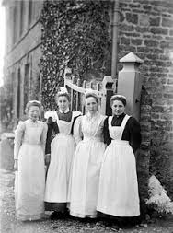
Women were already important in some industries before the war. They were used in the textile trade, as domestic servants and on the land. In particular the jute industry in Dundee relied on women. The success of such industries was linked to the low pay they gave women workers. On average it was 45% of what was paid to a man.

Various things restricted women and work; marriage was one as was the perceived ‘role’ of women, particularly true of the middle classes.

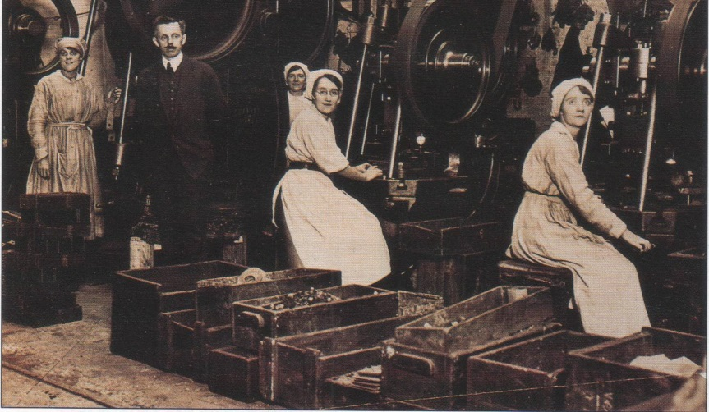
The war allowed women to, temporarily, step into jobs vacated by male workers serving in the armed forces or employed in heavy industries under the dilution scheme. By 1917 it was calculated that one in three working women were substituting male workers’ jobs.
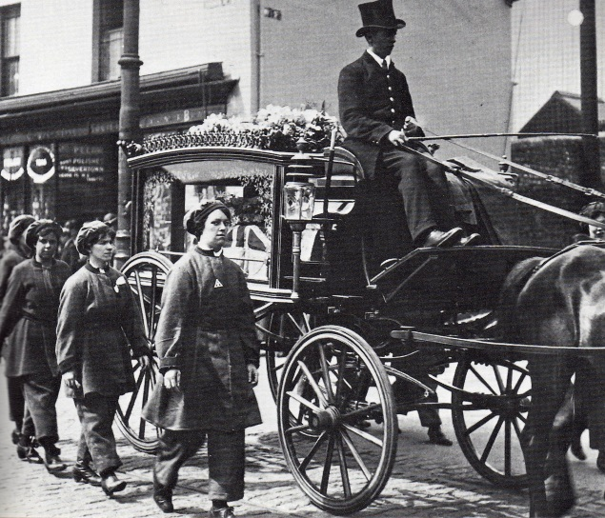
As casualty rates increased on the battlefield and conscription was introduced to swell the ranks, women were needed to fill the gaps on the Home Front. Industries that had previously excluded women now welcomed them and their contribution was undoubtedly important. However they still did not the same pay for doing the same job as men, although it improved on pre-war levels.

More women were employed in munitions work than in any other single industry. By the end of the war over 90,000 ‘munitionettes’ helped to produce guns, aircraft, shells and other types of ammunition. They faced considerable danger, not just from explosions but also from the chemicals they used. The work could be unpleasant and dangerous due to fumes and risk of cordite explosion - ‘devil’s porridge’.
TNT poisoning showed itself in many ways the workers could suffer from sickness, their skin became yellow leading to their nickname as canaries and their hair could turn orange. Although not appreciated at the time they also took the risk of becoming sterile and not being able to have children. In total, 61 workers died from poisoning and 71 from explosions.
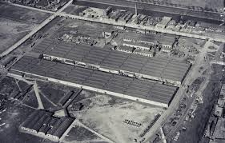
In some cases purpose built towns were built to house the vast factories needed, such as at Gretna Green. 9000 women and 5000 men worked there living in a purpose-built village that connected with the works via a light railway. Order was maintained by the Women’s Police Service. The girls would work 12 hour shifts and stay on site in barracks. They have to be prepared for emergencies like explosions facing more danger than men on home defence.

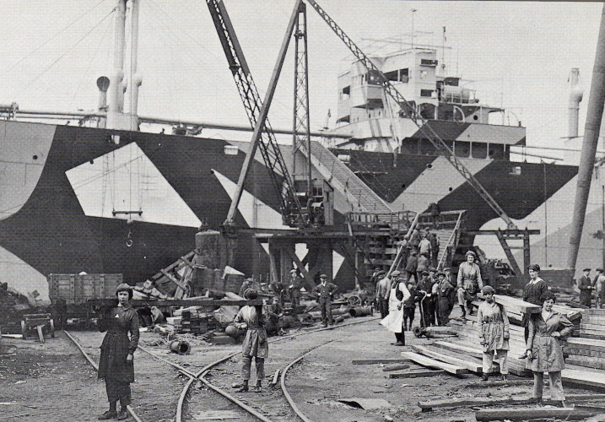
Although the munitionettes deserve great credit for their efforts to help win the war, there were many other ways that women helped.

Women worked on the trams, buses and railways. They took over men’s jobs in the shipyards and in the rubber industry. Many worked as typists and secretaries and nearly 200,000 women found work in government departments. Dilution of labour allowed women into previously skilled engineering jobs. Thousands worked on farms, at the docks and even in the police.
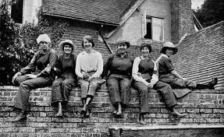
For some others the war did not make such a difference and women continued to work in the Jute industry much as they always had.

Land Girls
Although a considerable number of women had been employed in agriculture before 1914, many more were needed to replace the thousands of male farm labourers who joined up. The Women’s Land Army, formed in 1917, provided women for almost every type of farm work, including ploughing, labouring and livestock farming. There were 230,000 women working on the land in 1918.

Transport Workers
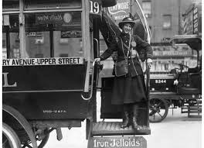
Well over 117,000 women worked in transport in 1918 compared to only 19,000 in 1914. Female porters, ticket collectors, carriage cleaners, conductors and guards had become a familiar sight on the buses, trams and railways by the end of the war.
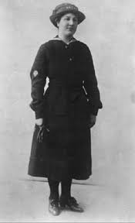
Work in the armed forces
WRNS (Wrens)
The women’s Royal Naval Service was formed in November 1917. It took over shore duties from the Royal Navy. They cleaned torpedoes, decoded messages, and made mine-nets, depth charges and sails, in addition to cooking and clerical work. Some Wrens also served overseas, e.g. in Malta, Gibraltar, Genoa and Ostend.

WAAC
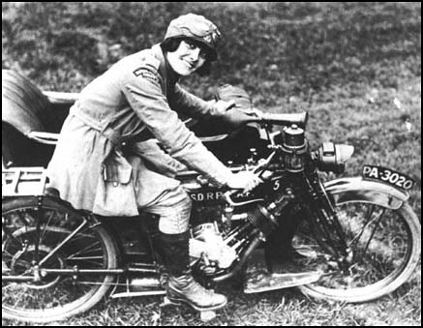
The Women’s Army Auxiliary Corps was formed in 1917 to release men for the fighting line. The WAACs served as typists, clerks, telephonists and drivers. During the war nearly 60,000 women joined, 10,000 of whom served in France.

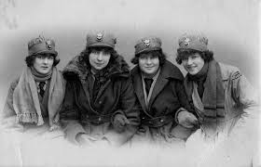

WRAF
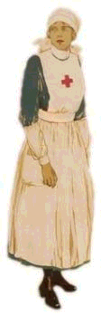
The Women’s Royal Air Force was formed in April 1918, at the same time as the RAF. Most WRAFs did clerical and domestic work mainly, but some were employed as fitters, riggers , welders and electricians.

Nursing
Volunteers for the Red Cross did various duties including nursing formed Aid Detachments, whose members were popularly known as VADs. At first entirely voluntary, VADs were given some payment as hospital war work increased. There were also fully trained nurses, frequently in France such as Mairi Chisholm. The Scottish Women’s Hospitals were one remarkable example of people wanting to contribute to the war in a positive way. They were idea of the remarkable Dr Elsie Inglis who had been a campaigner for the vote before the war. She proposed field hospitals near the front. Rejected by the British she found a more positive response from the French and Serbian governments. She raised money and organised the setting up of field hospitals. The Scottish Women’s Hospital served throughout the war in both Serbia and France. The French one treated over 10,000 service men. She died on returning from the Russian front where the Scottish Women’s Hospitals had been helping Serbian and Romanian troops.

Women were becoming more involved in politics
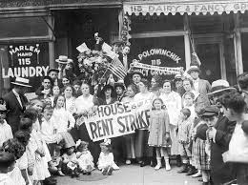
As a result of the new situation women such as Helen Crawfurd, Mary Barbour, Agnes Dollan and Jessie Stephens became involved in politics. The rent strikes in Glasgow in 1915 were almost entirely run by women and some of them got involved in organisations such as the Peace Crusade.

Changing Attitudes towards women.
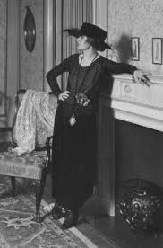
There were other ways that attitudes towards women changed during the war. Before the war the suffragette movement alienated many men who thought of pushy women as trouble makers but after the suffragettes called of their militant campaign ad gave full support to the war women were seen as patriotic and responsible. The view of middle class women being restricted to domestic life was challenged by them taking over men’s work in the workplace.
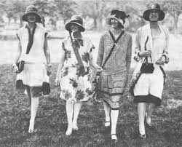
As a result of this, women earned good wages and many had money of their own for the first time. It became more acceptable for women to go out on their own, to wear cosmetics, and to smoke and drink in public places. Universities and professions such as medicine and law began to accept women. Although many of the gains of the war went into reverse with soldiers returning from France expecting their jobs back and got them, one thing did change: the Representation of the People Act gave women the vote in national elections for the first time.

The war had showed their economic value and resulted in a fundamental change in attitudes towards women and their role. It also opened the eyes of men to their capabilities and revealed them as citizens in every sense.
Many women now ‘head of the house’ as their men were away at war. Looking after families as well as working. They had to cope with worry and grief as well as getting on with things.
It gave women financial independence and improved their self-respect. Robert Roberts noted that ‘It undoubtedly snapped strings that had bound them in so many ways to the Victorian age. Wives in the shop no longer talked about ‘my boss’ or ‘my master’. Master had gone to war and Missus ruled the household, or if he worked close to her in a factory, turning out shell cases on a lathe and earning little more than she did herself. Housewives left their homes and immediate neighbourhood more frequently, and with money in their purses went foraging for goods even into the city shops, each trip being an exercise in self-education. She discovered her own rights’ .
The war had opened the ’Pandora’s box’ of letting women realise that they were just as rational as men and could live in the public sphere. Once they had found this out, they were unlikely to ‘unlearn’ it after the war finished.
Questions
1. Describe the jobs carried out by women during World War 1. 5
2. In what ways did the First World War result in changed attitudes towards women in Britain? 5
Source B: from an article in The Daily Telegraph, 1916 written by the journalist Rebecca West about the Gretna munitions workers.
The 250 girls work a twelve-hour shift before returning to the barracks where they live two miles away. The girls who take up this work sacrifice almost as much as men who enlist and have to be ready to face an emergency, for example only two days ago an explosion of air with chemicals ignited the cordite. Two huts were gutted, and one girl lost a hand. Surely, never before can women have lived lives so completely similar to that of the regular army. They face more danger every day than any soldier on home defence has seen since the beginning of the war. It is because of this army of cheerful and disciplined workers that this cordite factory has been able to increase its output since the beginning of the war by something over 1500 per cent; the country owes them a great debt.

Evaluate the usefulness of Source B as evidence of the impact of the war on Scottish women? 6

