The Battle of Loos
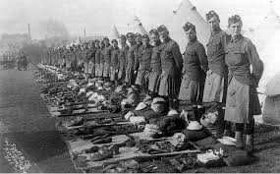
The battle of Loos was one of the first of the great battles of World War which included regiments from all over Scotland. About half of the 72 Battalions were from Scotland. After the battle was over some 7,000 Scottish soldiers had been killed from many of the small Scottish towns and villages as well as the major cities. As was said at the time, England’s loss was national while Scotland’s was personal.
The battle was in many ways unnecessary, as it was mainly to help the French. Haig, the British commander did not want to attack as he felt his troops were not trained sufficiently. He was also worried about the land which offered little cover to attacking troops.
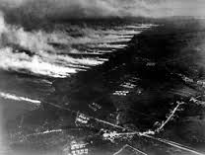
To overcome these problems the British used a massive artillery bombardment, which took away any chance of a surprise attack. They also used a new weapon for the first time, chlorine poison gas. This required a wind to blow it over the German trenches at it was to be released from the British lines.
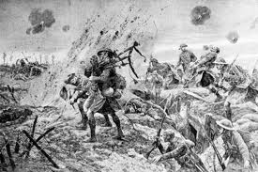
The battle began on the 25th September 1915 after a 4 day artillery bombardment with an attack including 2 Scottish divisions and all of the famous Scottish regiments. Many of the troops were affected by their own side’s gas as there was no wind to blow it over the German lines.
One of the first Scottish V.C’s was won during this battle by Piper Laidlaw of the K.O.S.B. as he piped his battalion into the attack. Despite being seriously wounded in his left ankle and leg he continued to play and encourage the troops.

Despite frightening casualties the Scottish attacks were successful but needed immediate reinforcement. Haig demanded reserves to back up his attack. They had been held some 16 miles behind the front and by the time they reached the front the Germans were waiting and their machine gunners slaughtered the new untried troops.
Although the battle dragged on till 19th October any real chance of a breakthrough was over by the end of the second day.
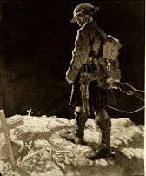
Loos could have been a victory with reinforcements but became known as the first of many inconclusive “nearly” battles with enormous casualties.
Scotland’s casualties were especially severe. Her regiments were connected to particular parts of the country and every part of the country was affected. At this time an attack battalion was about 700 men and officers.
Division losses
15th (Scottish) Division: 6,896 of which 228 were officers
9th (Scottish) Division: 6058 of which 190 were officers
Regiment | Recruiting Area | Losses | Battalions
Black Watch | Dundee, Fife & Perthshire | 1191 | 2 Battalions
Kings Own Scottish Borderers. | Borders and Edinburgh | 1664 | 3 Battalions
Highland Light Infantry | Glasgow | 1559 | 3 Battalions
Scottish Rifles | Lanarkshire | 485 | 1 Battalion
Scots Guards | All over Scotland | 474 | 1 Battalion
Gordon Highlanders | Aberdeenshire | 678 | 2 Battalions
Argyll & Sutherland Highlanders | Argyl l& Sutherland and Stirling | 330 | 1 Battalion
Royal Scots | Edinburgh and the Lothians | 1012 | 3 Battalions
Royal Scots Fusiliers | Ayrshire | 386 | 1 Battalion
Cameron Highlanders | Invernesshire | 814 | 2 Battalions
Seaforth Highlanders | Northern Highlands and Islands | 502 | 1 Battalion

Probably the main effect of the battle was the promotion the Scot, Douglas Haig to replace Sir John French as Army commander with Field Marshall Robertson as his subordinate. This was important as both believed the war could only be won on the Western Front.
There were some long term lessons which could have been learned but which plagued Generals throughout the war.
Long bombardments did not work but lost the element of surprise, gas was unpredictable, it was difficult to move up reinforcements quickly, communication was difficult in a battle and the New Army units were brave but as yet untrained.
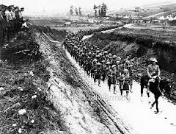
Tasks
Source B
The private Papers of Sir Douglas Haig . A letter to Lord Kitchener:
"Wednesday, 29th September 1915.
My dear Lord Kitchener,
You will doubtless recollect how earnestly I pressed you to ensure an adequate Reserve being close in rear of my attacking Divisions, and under my orders. It may interest you to know what has happened. No Reserve was placed under me. My attack, as has been reported, was a complete success. The enemy had no troops in his second line, which some of my plucky fellows reached and entered without opposition. Prisoners state the enemy was so hard put to it for troops to stem our advance that the officer's servants, fatigue-men, etc., in Lens were pushed forward to hold their second line east of Loos and Hill 70. The two Reserve Divisions (under C-in-C's orders) were directed to join me as soon as he success of First Army was known at GHQ. They ...crossed our old trench line...at 6pm.
We had captured Loos 12 hours previously. We were in a position to make this the turning point in the war... but naturally I feel very annoyed at the lost opportunity"
How fully does Haig’s letter give the reasons for the failure of the Battle of Loos 6
Evaluate the usefulness of the above Source A in showing the effects of the Battle of Loos for Scotland. (You may want to comment on who wrote it, when they wrote it, why they wrote it, what they say or what has been missed out.) 6
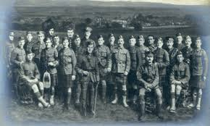
Evaluate the usefulness of the above Source B in showing the effects of the Battle of Loos for Scotland (You may want to comment on who wrote it, when they wrote it, why they wrote it, what they say or what has been missed out.) 6

