Scotland on the Eve of the Great War.

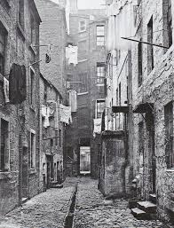
By 1900 most of Scotland’s population lived, like today, in the industrial central belt. Most of them lived in the main industrial cities of Glasgow, Edinburgh, Dundee and Aberdeen.

These cities were overcrowded with many working class people living in one or two roomed houses with shared toilets with other families. Although the country was becoming richer, this wealth did not find its way down to the working classes.

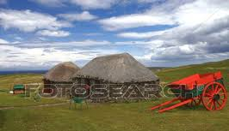
However many people were leaving Scotland altogether and emigrated to Canada, USA or Australia. At the same time there was still significant immigration into Scotland from Ireland, Italy and Lithuania.

The Highlands had changed dramatically in the 19th century and were now sparsely populated with little industry and poor crofting farms. This land question was an unresolved problem by 1914.

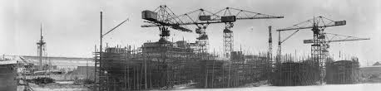
The Scottish economy was dominated by heavy industry. Shipbuilding, engineering, coal, iron and steel were the basis of the economy and provided most of the international trade that the country needed to survive. As Britain could not grow all the food she needed to survive, she needed to import 70% of her food to stay alive. This would have a dramatic effect when war came. Even then there was a drift of factories abroad where factory owners could pay less wages and make more profit, such a jute mills in Calcutta rather than Dundee. However, as Scotland was part of the British Empire her economy and opportunities for her people were world-wide. This interdependence on trade and its effect on Scotland can be shown in agriculture where the wheat many Scots ate was grown in Canada but the ships and railway engines which transported it were made in Glasgow in Scotland while the financial investment might have come from Edinburgh Insurance companies.

In short Scotland was heavily dependent on trade and any war which disrupted trade were bound to have an effect on the economy.

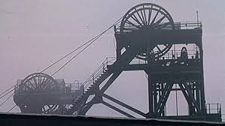
Coal was Scotland’s fastest growing industry as it powered steel and shipbuilding. However there had been little investment in the industry and many of its methods and machinery were becoming outdated with much of the work still being done by muscle power. Domestic usage was trimmed by people using oil, electricity and gas to heat and light their homes.

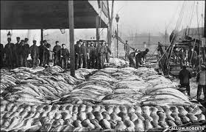
Steel was another major industry with the Beardmore forge in Parkhead making strong steel to be used by the navy in the Dreadnought race with Germany. Shipbuilding in general was another major trading industry with the Clyde having some 4 yards in operation to make the ships needed to trade with the Empire. Indeed by 1914 some 20% of the world’s shipping was Clyde built.

Fishing increased as an industry with the advent of the railways to transport fresh fish to the cities. The Herring fleets round Scotland’s port were both a familiar sight and a major employer. Much of this was exported to Russia, but what would happen if a major war disrupted this trade.

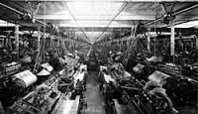
The textile industry was in decline but was still a major employer. In Dundee, for example, Jute was brought from Bengal, to Dundee, softened by whale oil, another Dundee industry, and made into sacks, nose bags for horses. However, Scottish investment was now building factories in India as it was cheaper. Cotton thread was another major employer in Paisley and the offshoot of sewing machines led to the Singer factory in Clydebank being the largest factory in Europe.

If this was the story in the Lowlands, it was different in the Highlands. What little industry there was did not employ many people and the land question dominated as crofting was still the major job for Highlanders.

To sum up, although the economy looked healthy, with international trade booming, a Naval race keeping shipbuilding going and good markets for Scottish Herring, coal and steel, far too much of this was based on trade and if a war disrupted trade the Scottish economy was bound to suffer.

Scottish Politics was also very different. The Liberals were “Scotland’s choice of party” for most of the 19th century with the Conservatives, Unionists and Labour distant seconds. The Liberal Party seemed to Scots to champion the cause of the “little man” against privileged aristocracy and big business. In the Highlands where many landowners used their estates for grouse shooting and the Land Question was unresolved, this struck a chord with many Scots. New Liberal ideas of intervention to help poor people also affected many industrial working class voters. This led to many of the newly enfranchised working men voting Liberal on a regular basis.

The Unionist Party stood against the Liberals on the important issue of Home Rule. The Liberals had championed Home Rule for Ireland which spilt the party for a while. Liberal Unionists and Conservatives joined in 1912 to the Scottish Unionist Party to keep Scotland in the United Kingdom. However the Conservatives were tarred with the brush of supporting the big landowners and landlords who were accused of making profit from high rents for poor houses. They also wanted to charge tariffs for food imported from abroad to protect British farmers, especially in the South East of England, but this would damage British trade which would have an undue effect on the Scottish Economy.
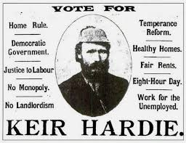
The Labour Party was born in Scotland in 188 to represent working class voters. However it was early days and by 1914 only 3 out of 42 MPs were returned from Scotland.

Scottish identity in the years before World War One was very much tied in with being British. The Empire gave Scotland markets for her goods and opportunities for her people and there was no real political will to split the Union.
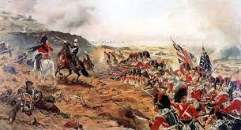
However there was a particular Scottish pride based on the Queen’s (Victoria) liking for the traditional Highland ways and “Balmoralism” was a view of the country current at the time. Although most Scots were Lowland, Kilts Tartan and pipes gave Scots a chance to show their difference from English people. This was especially true in the Scottish regiments which showed both their distinctive Scottishness and imperial Britishness.

Practice Question

Source A is about what Scotland was like before 1914. It is by Tom Devine and Richard Finlay, both modern historians.

At the beginning of the twentieth century, Scotland by any measure was one of the great manufacturing centres of the world. The Clyde built nearly a fifth of the world’s total output of ships. In the Western Lowlands, the coal engineering and shipbuilding and metal manufacturers sent products to all parts of the globe. The great fact of Scottish industry in the twentieth century was how that industry declined.

Evaluate the usefulness of Source A as evidence of what Scotland was like before 1914?
(You may wish to comment on who wrote it, when they wrote it, why they wrote it, what they say and what has been missed out.) 6

