Recruitment and Conscription

Information

The Introduction of Conscription, 1916
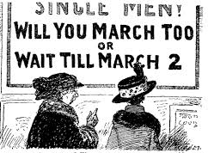
Even before war broke out parliament had debated the issue of conscription at least four times. Supporters of conscription argued that young men had a duty, above all else, to defend their country. When the voluntary recruitment rate seemed to fall after the initial rush in the late summer of 1914, the calls to introduce conscription became louder.
Both Germany and the opposing Allied Powers had expected a short war, with rapidly moving armies and decisive battles. During the first month of the war, a total of 500,000 men had volunteered to serve in the Army. Over the next eighteen months men were still volunteering at a rate of 100,000 a month, but many people in Britain were complaining that hundreds of thousands of men of military age were not joining the armed forces. In September 1914 the German advance was stopped at the Battle of the Marne. The opposing armies dug themselves into equally strong positions in trenches, defended by barbed wire and machine guns. From these defensive positions the two sides would take turns in making massive frontal attacks on each other’s trenches. These tactics were very costly in terms of human lives, but were unable to bring about a military victory. By the end of December 1915, British casualties totalled 528,227 killed, missing or wounded and it was clear to the government that even the large number of volunteers joining the Army was not going to be enough. It was now obvious that there would be no quick victory. By late 1915 the war was spreading to other fighting areas beyond France and more men were needed. Machine – guns were slaughtering thousands every day. A more drastic way of recruiting men was needed, and so for the first time in British military history, conscription began.
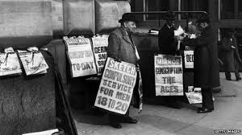
The large lists of casualties being published in newspapers meant that people began to realise that this war was very different to previous wars and by 1916 the number of men volunteering was far less than in the early stages of the war. Herbert Asquith, the British Prime Minister, announced that it had become a “war of endurance” with final victory going to the side “which arms itself the best and stays the longest.”
The Military Service Act.
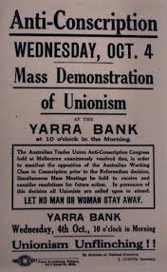
Therefore, for the first time ever, a British government introduced conscription. Men were ordered to fight in the war. Under this measure unmarried men between the ages of 18 and 41 were “deemed to have enlisted for general service.” Four months later, in May 1916, conscription was widened to include married men and, by April 1918, in the last year of the war, older men up to the age of 51 could also be “called up” to join the fighting forces, especially the Army.
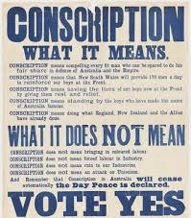
Conscription was the compulsory enlisting of men into the forces, even if they did not want to go. Certain men were exempt, particularly those with vital industrial skills, but most between the ages of eighteen and forty – one were liable to be “called up”. Unlike volunteers they could not choose which regiment to serve in. They were simply sent wherever they were most needed.
The “Conscience Clause”
The most unusual feature of the Military Service Act was the inclusion of a “conscience clause”. This stated that a person could refuse military service if it went against their ideas of right and wrong. Men who objected to fighting in the armed forces on “conscience grounds” could argue their cases at a Tribunal, a court without a judge or jury, and if they could convince the Tribunal that they were genuine and sincere in their beliefs, they could be freed from military service.
Britain was the only major country in Europe to have a “conscience clause”. In other European countries, men who refused to fight were imprisoned and, in cases, shot as deserters or declared insane and sent to asylums.
Task

Source B: from William Kenefick, War Resisters and Anti-Conscription in Scotland: an Independent Labour Party Perspective (1999).
Scots responded in great numbers to the call to arms at the outbreak of war in 1914 and by December 1914, 25% of the male labour force of western Scotland had signed up. However it was being reported throughout the press from as early as October that the numbers enlisting were falling slightly. It seemed, according to the editors of Forward
that “the Cannon fodder was rather backward in coming forward”. There was a serious side to this issue as even a slight fall in recruitment meant that the topic of conscription was raised. If matters had been left to the Scottish press the decision to introduce compulsory military service would have been a foregone conclusion. The Glasgow Herald
reported in December 1914 that if voluntarism did not work then conscription was the only alternative. The Daily Record ran similar articles promoting support for conscription. Despite the National Registration Act, recruitment levels fell to around 80,000 per month by January 1916 and conscription became a reality.

Source C: from Trevor Royle, The Flowers of the Forest (2007).
Within a day of the declaration of war, the recruiting office in Edinburgh’s Cockburn Street was doing brisk business and, by the end of August 20,000 recruits had been processed. In Glasgow six thousand men enlisted over the very first weekend of war and from across Scotland came news of equally high figures. However, the number of volunteers began to fall off in 1915. There were increasing concerns that compulsory military service would be introduced and anti-conscription rallies had been held in Glasgow
since the end of 1915, one meeting being addressed by committed anti-war protestors Sylvia Pankhurst and John MacLean. The National Registration Act of July 1915 required all persons to register for possible service which helped to maintain the Liberals’ belief in the voluntary principle as most Scottish Liberal MPs were opposed to conscription. The national registration scheme however proved to be cumbersome and unworkable and recruitment continued to fall and, though long resisted, compulsory service became inevitable resulting in the Military Services Act of 1916.

To what extent do Sources B and C agree about recruitment and conscription in Scotland?
Compare the content overall and in detail. 5

Marking Scheme

The candidate makes a judgement on the extent to which Sources B and C agree about recruitment and conscription in Scotland, in terms of:
Overall: Source B and Source C agree that Scots volunteered in great numbers at the outbreak of war and that recruitment fell as the war progressed.
Both also agree that the National Registration Act did not work. Source B however shows newspaper support for the introduction of conscription whilst Source C mentions the
Anti-conscription rallies taking place in 1915.

Developed through detail:
Source B | Source C
Scots responded in great numbers... indeed by December 1914 25% of the labour force of Western Scotland had signed up. | 20,000 recruits in Edinburgh by end of August and in Glasgow over the first weekend of the war six thousand men enlisted.
It was being reported throughout the press from as early as October that the numbers enlisting were falling slightly. | The number of volunteers began to fall off in 1915.
The Glasgow Herald reported in December 1914 that if voluntarism did not work then conscription was the only alternative. The  Daily Record ran similar articles promoting support for conscription. | There were increasing concerns that compulsory military service would be introduced and anti-conscription rallies had been held in Glasgow since the end of 1915, one meeting being addressed by  committed anti-war protesters Sylvia  Pankhurst and John MacLean.
Despite the National Registration Act  recruitment levels fell to around 80,000 per month by January 1916 and conscription became a reality. | The national registration scheme proved to be cumbersome and unworkable and recruitment continued to fall.

