Pacifism and Conscientious Objectors

Information
Opposition to the war
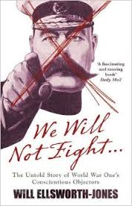
When war broke out thousands of young Scots rushed to join up and “do their bit”. However, not everyone supported the war effort. Some did not believe the propaganda that was meant to create anti-German feeling and stoke up a “war fever”. There were many people in Scotland who opposed the war, did not wish to volunteer and then resisted conscription.

In 1914 Clifford Allen and Fenner Brockway had started an organisation called the No Conscription Fellowship (NCF). Public opinion had little sympathy for conchies and newspapers described the NCF and ILP as cowards, peace cranks and ‘pasty faces’.
Religious groups and churches were divided over the issue. The Church of Scotland officially supported the war effort and the Moderator, Sir George Smith publicly attacked conchies in his speeches. Some spoke out, Rev McCallum warning ‘this was neither God’s war nor a Holy war!’ The Quakers opposed all war as being against Christianity.
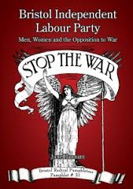
Anti-war opinion was not popular. Led by Keir Hardie, the strongest political group to oppose the war was the Independent Labour Party (ILP) which immediately attacked the official Labour Party’s support for Kitchener’s recruitment campaign. The ILP’s newspaper called Forward was often criticised and even closed down for its persistent attacks on government policy. In the pro-war atmosphere of autumn 1914 any voice that asked for compromise and rational thought about how to stop the war was shouted down as unpatriotic and a threat to Britain’s safety. By the end of 1914, ILP membership was down to 3,000 and the party was described as a pacifist group which threatened to dampen the war enthusiasm of the nation. However, many thousands of Scots had listened to and become convinced by its anti-war message. ILP membership had increased from 3.000 to 9,000 by 1918.

The Union of Democratic control was another organisation that opposed conscription and wartime censorship along with other restrictions on civil liberties. The UDC was not linked to any one political party but as both the Liberal and Conservative parties actively supported the war, the UDC became dominated by left-wing Liberal and Labour activists. Scottish political figures such as Ramsay MacDonald, Tom Johnston and David Kirkwood were members of the UDC and became well known for their radical policies and actions during the war. By 1915 the Union of Democratic Control had 300,000 members and was the most important of all the anti-war organisations in Britain. Members of the UDC were under constant threat from members of the public who believed the UDC was a cover organisation for supporters of Germany during the war – in other words, traitors. The Daily Express suggested that the UDC was working for the German government. It published details of future UDC meetings and encouraged its readers to go and break them up.
By the end of the war the UDC still had over 10,000 members, showing that public opinion did not always support the war, despite what government propaganda would have liked the people to believe.

Helen Crawfurd, one of the leaders of the Rent Strikes, on 10 June 1916, launched the Women’s Peace Crusade, the first concerted effort to involve people in all social classes to oppose the war. It had some success: by summer 1917 there were branches all over Scotland and it attracted 14,000 protesters to a mass meeting held on Glasgow Green. Other organisations included the Women’s International League for Peace and Freedom founded by Chrystal Macmillan, a graduate of Edinburgh University.

However, the number of pacifists and war resistors was tiny – calculated at less than half of one per cent of the population.

Conscientious Objectors
In 1914 men had flocked to join the army. But, as the war ground on, they were less keen to volunteer. By late 1915 it was clear to the government that even the large number of volunteers joining the Army was not going to be enough. The war was spreading to other fighting areas beyond France and more men were needed. Machine – guns were slaughtering thousands every day. Therefore, during January 1916 the Military Service Act brought in conscription for single men aged 19 to 40 years old. By May 1916 it included married men and by 1918 all men up to 50.
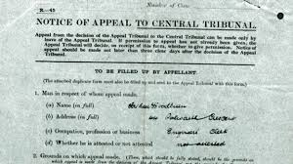
The Military Service Acts excused certain men from military service. Exemptions included those mentally or physically unfit, those doing a job vital to war industries, those who would cause serious hardship for their families such as a single parent, or conscientious objectors.

Some people disagreed with the war on either political or religious grounds. In Scotland 70% of all conchies were members of the ILP, who claimed exemption on the basis of socialist principles.

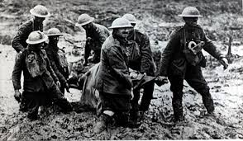
There was some opposition to conscription mainly on religious grounds. Some Christians thought it was wrong to kill at any time, and they refused to join the army. Others, mainly socialists, believed that the Government had no right to force men to fight for a cause they did not believe in. These men were known as conscientious objectors. That is, their conscience would not allow them to fight in the war. Military Tribunals were set up to judge whether or not to accept the claims of conscientious objectors or treat them as just cowards or shirkers. Around 7,000 conchies granted exemption accepted non-combat duties such as stretcher bearers in the front line or ambulance drivers, went to the front and showed great bravery.

There were also ‘alternatives’ who were prepared to undertake civilian work to help the war effort which was not supervised by the military – work in munitions factories. Many Scottish socialists, such as James Maxton, took this option.
Some other conscientious objectors were absolutists who refused to have anything whatsoever to do with the war. Between 1914 and 1918 in the UK 5970 ‘absolutists’ rejected any service and were imprisoned.

The Home Office Centres.
In June 1916, Asquith (the Prime Minister) announced a new plan for dealing with conscientious objectors. Under the Home Office Scheme the objectors in prison would have their cases re – examined by the Central Committee, and those found to be sincere in their objections would be released “on their undertaking to perform work of national importance under civil control”.
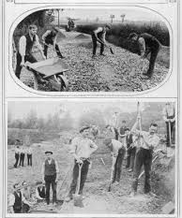
Absolutists rejected the plan as another form of conscription, because for many “work of national importance” meant helping the war effort. However, 3,700 imprisoned objectors did accept the offer of a place under the Home Office Scheme, and the first Work Centre was set up at Dyce, near Aberdeen. In August 1916, 250 men were transferred to the Dyce camp from the prisons. They were housed in old army tents near a granite quarry where they were to break up stone for road building. While the summer lasted, the experiment appeared to be a success, but heavy September rain turned the camp into a sea of mud.

Following the death of one of the conscientious objectors, the Home Office closed the Dyce camp and dispersed the inmates to other centres, although some had already chosen to rejoin the absolutists in prison when they discovered that the stone taken from the granite quarry was being used to build a military road.

A total of 24 conscientious objectors died while based at the Home Office Work Centres. Following the failure of the Dyce camp, the Home Office set up new centres, several in converted prisons. At Knutsford Wakefield, Warwick and Dartmoor, locks were removed from cell doors, the warders, out of uniform, became “instructors”, and the men were allowed out in the evening until 9.30.p.m. As the most common jobs were stone breaking and mailbag sewing, the “work of national importance” was still close to “hard labour”. Discipline was harsh and, even for the slightest offence, an objector could be sent back to prison. The objectors also faced fierce hostility from the local population – in prison the objector was totally isolated, while the greater freedom of the Centres made him an easy target for abuse and violence. In Lyme Regis, Lyndhurst, Wakefield, Knutsford and Dartmoor, objectors were badly beaten up by angry mobs.
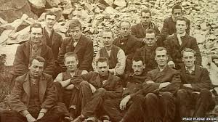
In Prison
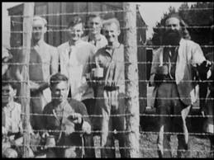
The Army saw thousands of objectors who had been “handed over” to them for military training not only as an embarrassment, but a threat to discipline so they sent them to a civil prison. They would still technically be soldiers, but not the Army’s responsibility.
The usual sentence given to conscientious objectors was two years imprisonment with hard labour, which, in the early stages, was generally reduced to 112 days. However, as soon as he was released he would be returned to his army unit, and again be arrested for refusing to obey orders. Under this system, he might face an endless series of prison sentences, though in practice only three men received the maximum total of six sentences. It was expected that the repeated sentences would break down the resistance of the objectors. In fact, only 351 men gave in and agreed to become soldiers.

Prison conditions were harsh. Under “hard labour”, the prisoner would be kept in a small, badly heated and poorly ventilated cell. On small rations, he would be expected to spend ten hours a day working. There was also a rule of total silence. If a prisoner refused prison work or took part in a prison revolt, he would be placed in solitary confinement. Such prisoners were not allowed to write or read letters, or even receive visits. A handful of conscientious objectors took part in hunger strikes. Eleven objectors in the prison at Newcastle were forcibly fed in what they claimed was a rough and brutal fashion, while in Hull prison a conscientious objector choked to death when being forcibly fed with a tube.
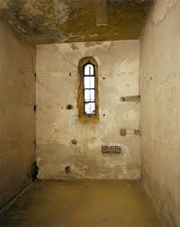
Ten conscientious objectors died in prison, while some twenty or more died shortly after their release from prison. Most of these were victims of tuberculosis, pneumonia or influenza. The No – Conscription Fellowship claimed that these objectors had died from such illnesses because of the poor food and cold, damp conditions in the prison cells or as a result of mistreatment and neglect by both medical officers and prison staff.
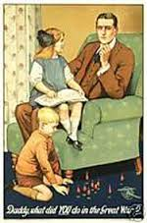
Peace
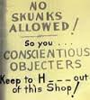
Although the Great War finally ended on 11th November 1918, the last of the conscientious objectors was not released till August 1919. They were given a note from the War Office telling them that they had been dishonourably discharged from the Army, and warning them that they would be liable to two years hard labour if they ever tried to re – enlist. The Non – Combatant Corps was not fully demobilized until 1920. According to the Conscientious Objectors Combatant Corps, 73 conscientious objectors died and 31 went mad as a result of their treatment by the authorities during the First World War.

The penalties for being a “conchie” continued into civilian life. Under a 1918 Act of Parliament, all objectors who had not joined the Army lost the right to vote for five years. There was also much discrimination shown against the objectors, e. g. in 1919 many employers were unwilling to give work to men who had no war record.

Task

Source A is a speech by James Maxton, a socialist who objected to conscription, at his tribunal.
I am a socialist and a member of a socialist organisation. As such I have worked to establish a better system of society, which would make for the peace and brotherhood of peoples of all lands. To take part in a war would for me be a desertion of these ideas, and I must therefore decline to take part.

How fully does Source A represent the ideas of conscientious objectors? 9

