Military Tactics in World War One
When the war started it was thought that it would be a war of movement and that the armies would march about until they met and fight an open battle. This was no different from the Battle of Waterloo 99 years before. In practice, after a short period of open warfare, when each side tried to outflank the other, the front lines became a series of trenches which went from the coast of the North Sea to Switzerland.

This meant that there was no chance of outflanking the Germans and any attack would have to be frontal. Generals tried to amass as many men at one place as they could, without the enemy knowing, and launch a massive attack to overwhelm them. Once through the trench lines, the cavalry could spread out and roll up the lines achieving a breakthrough.

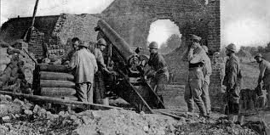
The process of the breakthrough was to reconnoitre the enemy positions to find a likely place to attack and quietly move troops to the front. Shortly before the attack the artillery would shell the German trenches and barbed wire to clear a way for the infantry. At the last minute some infantry men would try and cut more gaps through the barbed wire and when the attack was due the troops would rise up out of their trenches and advance across no man’s land.
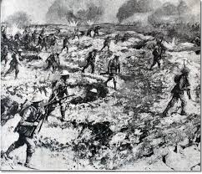
Frequently the artillery barrage did not work, leaving the wire uncut, and as soon the barrage stopped the Germans would rush to their guns and be ready for the attack. This meant that the casualty rate for the attackers was extremely high, and usually no impact was made on the German front line.

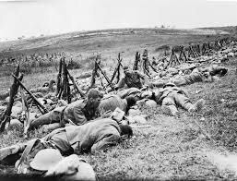
By 1916 it was clear that a breakthrough was almost impossible and the tactic changed to attrition. Instead of trying to win ground the object of the attack was to draw enemy soldiers into the battle and kill as many of them as they could. The reasoning was that if we had more soldiers than the enemy, if each of our soldiers killed 1 German before he was killed, there would be some British soldiers left and no Germans so we would have won.
Tasks

1. Describe how First World War battles were fought 5

The following sources are about the fighting on the Western Front.
Study the sources carefully and answer the questions which follow.
You should use your own knowledge where appropriate.

Source A is a Government photograph of British troops taking part in an attack on the Western Front in 1916.
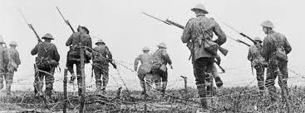
Source A

1)

1. Evaluate the usefulness of Source A as evidence of the fighting on the Western Front. 5
(You may wish to comment on who produced it, when they took it, why they took it, what it tells us or what has been missed out)
Source B describes trench warfare on the Western Front.
Source B
The stalemate on the Western Front meant that new tactics became more and more important. Yet heavy shells churned up the ground around the frontline. This created a barren landscape. Soldiers struggled to get out of their trenches to attack the enemy. Battles began to involve more and more soldiers. Once out of their often basic trenches, soldiers had to cross ‘no man’s – land’. Further dangers like shell craters and barbed wire waited there.
2. How far do Sources A and B agree about trench warfare? 4

