Improvements in Women’s conditions.

The campaigns for women’s suffrage can be seen in the context of changing attitudes within society towards women in the late 9th and early 20th centuries. The historian Martin Pugh stated that “their participation in local government made women’s exclusion from national elections increasingly untenable.” Millicent Fawcett argued that wider social changes were vital factors in the winning of the franchise. “Arguments against giving women the vote are both out of date and out of place when women have for years, by common consent, taken an active part in public affairs, when they are members of town councils Boards of Guardians and are prominent members of political organisations.”

They started to break into public life in the fields of Education, Legal rights and technology did improve some Employment opportunities. The pace of this change was painfully slow and some women believed that only getting the vote would increase the rate of improvement. Men were used to controlling these fields and were unwilling to easily give up their power. As long as they had power they could dictate the agenda and tell women what they could or could not do.
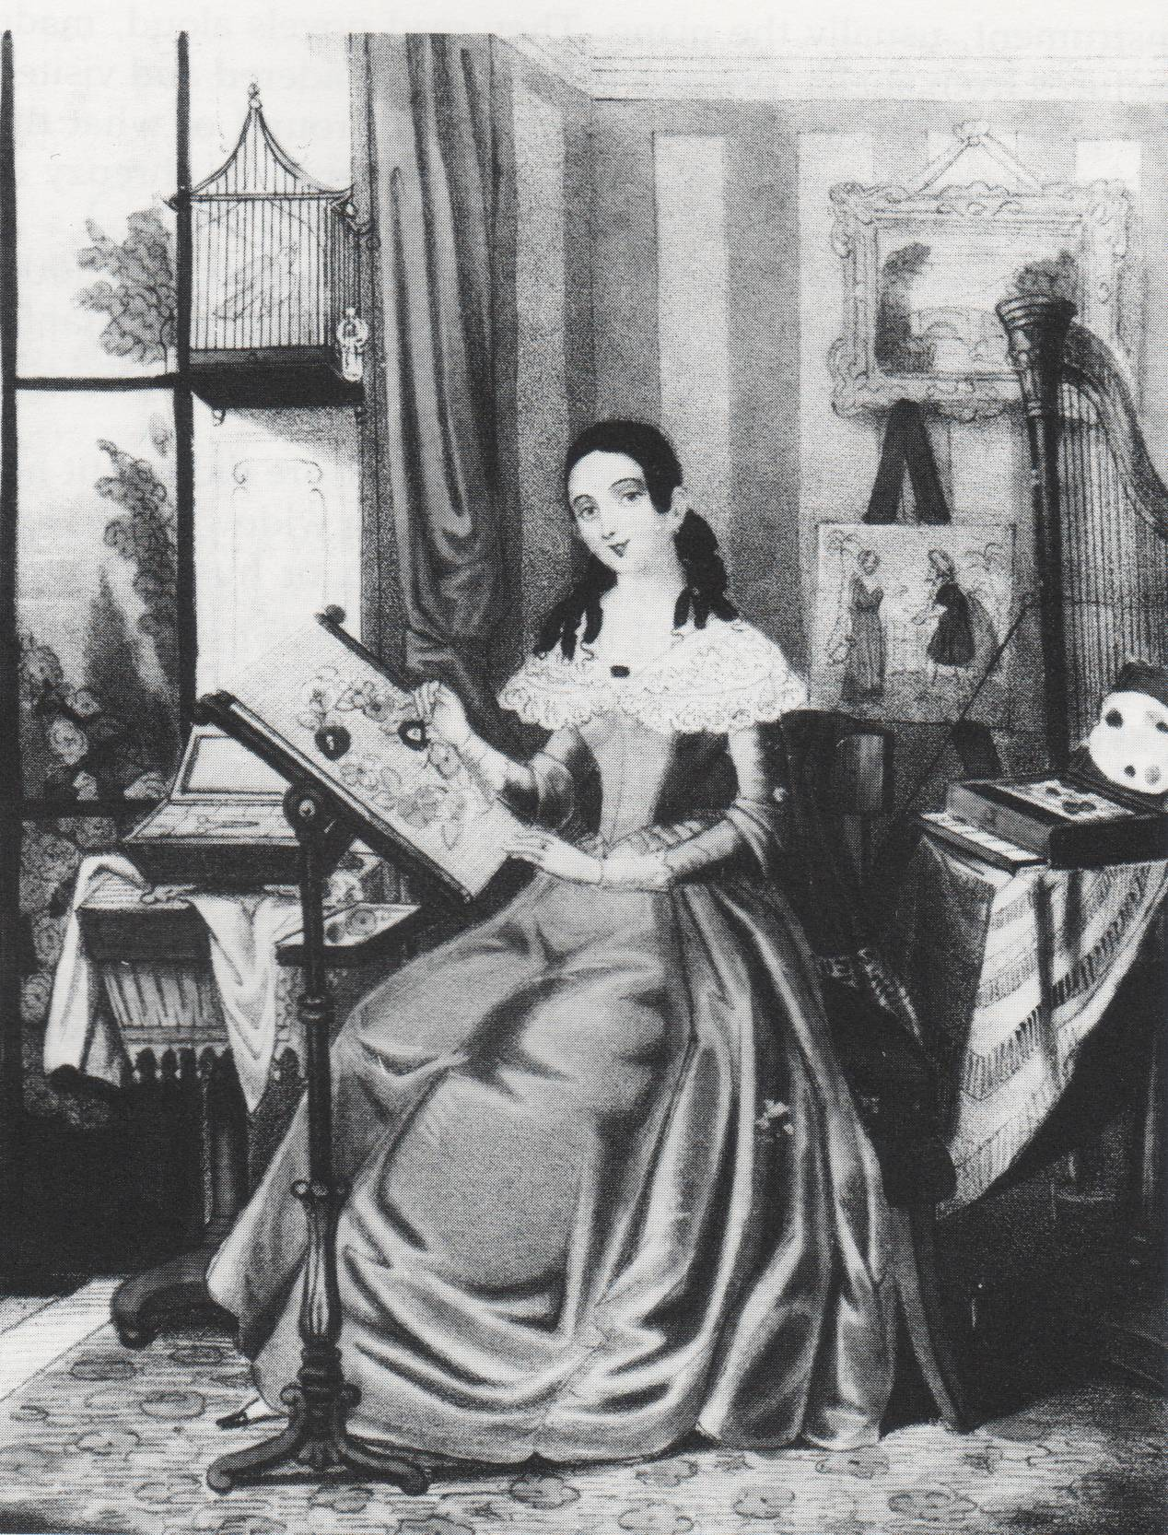

Education

Early on in the 19th century women were educated to be good wives and mothers, not for any kind of career outside the home. A man summed up this viewpoint at the time by saying “You can’t send your daughter into the drawing room reciting the multiplication tables, so why should she bother to learn it”.
Their lessons were planned mainly to find a husband. It was an education in learning social skills. So they were taught to sing, play the piano and dance; they learned how to speak French and make conversation. They usually also learned to do needlework to fill in any vacant hours after they were married. But these lessons were of little help if the girl did not get married.
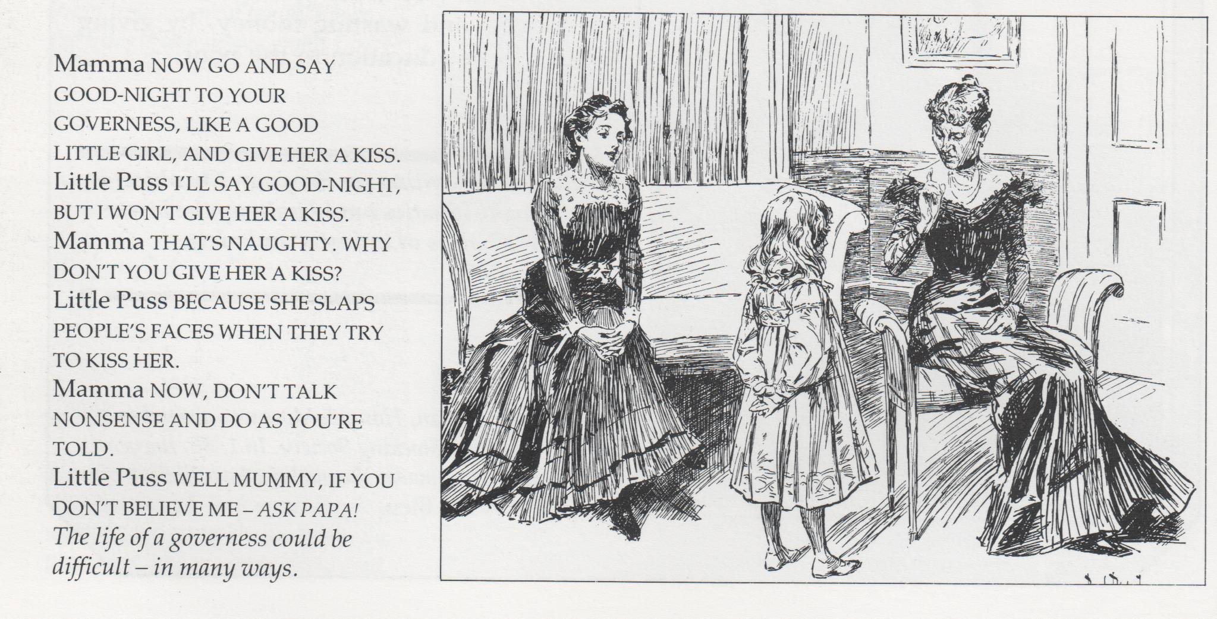
Their limited education reduced their choice of careers.

Ladies who did not get married faced few choices. Some stayed with their families and, perhaps relied on a brother’s support.

Others became paid companions to richer ladies. Many ended up as governesses, teaching other people’s children and living in other people’s homes, often earning no more than 25 pounds a year.

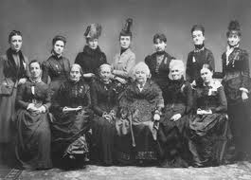
As the century progressed things did start to improve. In 1848, Queens College training college for women teachers was set up. In 1850 Francis Buss followed this up with the North London Collegiate School. In 1858 Dorothea Beale was appointed head of Cheltenham Ladies College. Miss Buss and Miss Beale had both attended Queens College. Cheltenham College gave girls a solid academic education. In 1871 Girls’ Public Day School Trust was set up to establish more such schools. From the 1870s girls were given primary education. In 1873 Higher Education became available when Girton College was set up at Cambridge University to be followed in 1876 by Newnham College. Oxford followed in 1879 with Lady Margaret Hall and Somerville College. However, they could attend lectures and sit exams but they could still not graduate. In 1878 London University allowed women to take degrees on the same basis as men. The four Scottish universities also allowed women in on the same basis as men. In 1910 Local authorities made a grammar school education equally available to boys and girls. In 1920 Oxford University allowed women to take degrees, followed by Cambridge in 1948.

Legal Changes

Legal changes started to give women rights such as the Infant Custody Act of 1873 which gave them more rights over their children and a better chance of custody in the event of a divorce. The Married Women’s Property Acts of 1882 and 1893 gave women full legal control of any property that they took into a marriage or any they had gained after through their own efforts or inherited.
- Women granted limited rights of access to children.
- Women allowed to divorce their husbands for desertion or cruelty
- Women allowed to own property and do what they liked with it.
- Women to receive financial support from their husbands if they deserted them.
- A mother became the legal parent of her children if their father was dead.
- Women householders were allowed to vote in local elections.
- Wives could not be forced to live with their husbands if they did not wish.
1907 Women could become Town Councilors.

Employment

Complicated changes. The Victorian period was a time of complicated changes in employment patterns for women. They were still involved in many areas of industry. Most women still worked as servants, in their own homes or in sweated trade which were not controlled by government laws. Opportunities did open up for educated women to work in the so called ‘white collar’ professions of teaching, medicine or clerical work, which were to become increasingly important in the 20th century. However, they were still barred from many professions. They could not be lawyers or architects, or even serve on a jury. In almost all jobs done by both men and women, women were still paid less than men.
At the same time as women’s opportunities in general were still being limited, various ‘female’ professions began to appear.

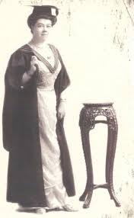
Teaching. During the 19th century the population of Britain increased dramatically. The number of schools also increased. Education was made compulsory in 1870, leading to a massive need for new teachers. Many classes were taught by older children who had stayed on at school, usually girls. By the end of the 19th century three quarters of all teachers were women. Even so, the most powerful jobs in teaching, e.g. as an inspector, were almost all carried out by men. A headmistress would be paid the same as the youngest male teacher. Women teachers also had to be single. If they married they had to resign, whether they wanted to or not.

Nursing During the 19th century many new hospitals were built. In 1860, the Nightingale School for Nurses was set up in London. By 1900, 60,000 trained nurses were working in British hospitals. Voluntary Aid Detachment Nurses won widespread praise for their work during World War One. Nursing became almost invariably a women’s job, but nurses had to resign when they married. A few began to qualify as doctors.

Shop Work By the early 1900’s the luckiest working class girls were finding work in the new shops that were appearing everywhere. It was ‘better class’ work and the smartest London shops paid £1a week, which was a good wage. But employees had to work an eighty four hour week and they had to resign when they married.

Clerical Work. In the early 19th century, clerical jobs such as writing up accounts in banks, letters and being secretaries were done almost exclusively by men. In the 1870’s the typewriter was invented and male clerks were gradually replaced by less well paid female typists. By the 1930’s clerical work was regarded as a predominantly female occupation. Most women office workers were from the middle class. The work was clean ‘ladylike’ and not as tiring as teaching or nursing. However male clerks were paid twice as much as women. Women also had to leave when they married.

Early Pioneers

During the 19th century a significant number of women turned against the conventional female role and carved out independent lives for themselves. They became leaders in various spheres of life and greatly influenced the society around them. At the same time, they encouraged people to reconsider the position of women. However, the fact these few names are so easily remembered shows how difficult progress was.
- Elizabeth Garrett Anderson became the first woman doctor in Britain in 1865. In 1870 she was appointed to a London hospital.
- Florence Nightingale nursed in the Crimean war and came home to set up nurses training schools in Britain as well as improving hospitals.
- Marie Lloyd was a very popular music hall singer who performed in Britain, America, Australia and South Africa.
- Mary Searle nursed in the Crimea and traveled in many countries.
- Annie Beasant was a campaigner for women’s rights, birth control and socialism.
- Josephine Butler was also a campaigner for women’s rights, birth control and socialism.
- Mary Kingsley traveled in West Africa and was an expert in local cultures.
- Charlotte Bronte wrote bestselling novels including Jane Eyre.
- Queen Victoria was queen of the United Kingdom and its Empire.

