Impact of the War on Scottish Society
Information
At the start of the war Scottish recruitment was a higher percentage than any other country in UK” and as a result Scottish forces suffered disproportionately higher losses.
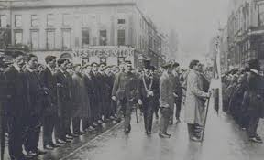
By the end of the first week in September 1914, Glasgow was able to boast that it had recruited more than 22,000 men. By December 1914, 25% of the male labour force of western Scotland had already signed up. 13% of those who volunteered in 1914-15 were Scots. Young Scots were urged to join the army through a mixture of peer pressure, feelings of guilt, appeals to patriotism, hopes for escapism and adventure, heroism, self-sacrifice and honour. For the unemployed, the army offered a steady wage.
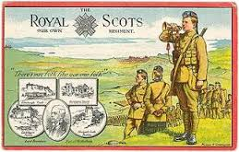
In Scotland there were no official 'Pals Battalions' but in reality –the Highland Light
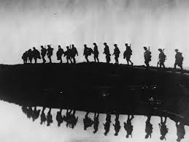
Infantry/Tramway battalion; the 16th battalion/the Boys Brigade battalion were formed by men who wished to serve with their friends. In Edinburgh, Cranston's battalion and McCrae's battalions became part the Royal Scots. McCrae's battalion was the most famous because of its connection with Hearts football club.

The official figure given at the end of the war calculated that Scotland had suffered
74,000 dead. However, it was guessed that the figure was much higher: of 557,000 Scots who enlisted in the services, 26.4% lost their lives. One in five British casualties was Scottish.

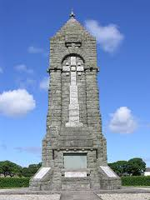
This slaughter remained to haunt the nation and led to a collective national grief in Scotland. However, there was also a great pride in the achievement of the Scottish units.
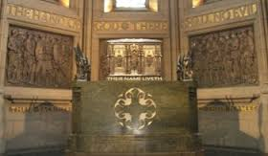
Local memorials were erected around the country but it was felt that the nation’s sacrifice demanded a National Memorial in tribute: Edinburgh castle was chosen and houses the memorial and museum. It was officially opened in 1928. Over 148,000 Scottish names are carved on the national war memorial.
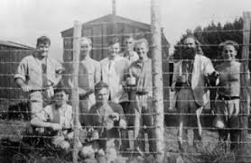
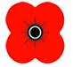
The British Legion was set up and in 1921 the British Legion Scotland. Poppy day started at the same time. The act of silence at 11am on 11 November started in 1919.

The war also led many people to question their beliefs and some decided that killing other people was wrong. Many Pacifism and Conscientious Objectors were Scottish and objected for religious, ethical or political reasons.

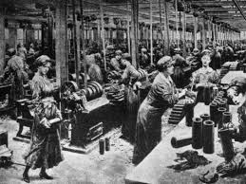
The War also revolutionised the position of women in the economy.
There was a shift towards military and manufacturing employment and a temporary decline in some service industries. The number of women working increased from 593,210 in 1911 to 638,575 a decade later. Before the war there were less than 4,000 women worked in heavy industry in Scotland. The number of women employed in munitions in Scotland rose to 31,500 by October 1918. As a result of this many women workers were used for “dilution” of labour. Women worked as conductors on trams and buses, as typists and secretaries and nearly 200,000 women found work in government departments.
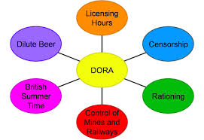
The Defence of the Realm Act (DORA) meant that the government direct control of industries, communications and resources, censorship of the press, imprisonment of war protestors, civilians could be tried under court martial, reduced hours of public houses etc.

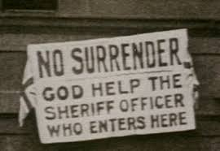
In Glasgow Rent Strikes saw a prominent role played by women like Mary Barbour, Helen Crawfurd and Agnes Dollan. These women would even physically oppose evictions and won with the passing of the Rent Restriction Act freezing rent levels and introducing state intervention in the private housing rental market for the first time.

Source B: from Nicholas Morgan, In War’s Wake, (1984).
During the four years of the war, recruitment to the armed forces from Scotland came to nearly a quarter of the adult male population, a higher percentage than any other country in the UK. Scottish forces suffered disproportionately higher losses than their English counterparts. Wartime, in particular, revolutionised the position of women in the economy, but women’s war-work, whether unskilled tasks such as shell-filling or the more skilled jobs, was intended to be temporary. In 1918 women demonstrated in Glasgow, protesting against their enforced removal from the workplace. The slaughter remained to haunt a nation. Grey granite war memorials sprang up in cities, towns and especially villages throughout the country, where lists of names often paid testimony to rural communities that were never to recapture the strength of their pre-war years.

How fully does Source B show the impact of war on Scottish society?
Use the source and recalled knowledge. 9
