Haig and Scots on the Western Front

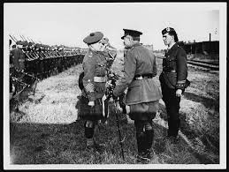
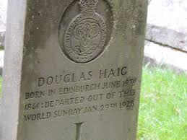
Sir Douglas Haig was born in Edinburgh in 1865 and was overall Commander of the British forces during World War One from December 1915 to the end in 1918. His first major battle in charge was the Somme which is remembered for the shocking casualties on the first day, 1st July 1916. However the battle continued till 13th November and the losses of the first day were never repeated. He was aware of the huge contribution made by Scots in the war and mentions his sympathy for those mourning the countless thousands of Scotsmen who died. However, he states that Scotsmen served their country well which offers some consolation. After the war he set up the Haig Foundation, based in Edinburgh, to care for wounded and maimed soldiers who had survived, which belies his reputation as a “butcher” who did not care about his men. He is buried in Dryburgh Abbey in the borders under an ordinary soldier’s gravestone, just like the thousands to be found in France.

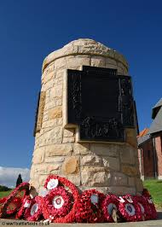
Haig mentions the thanks he owes to McCrae’s battalion giving tribute to them for serving their country so well on 1st July at the Somme. This battalion was raised in Edinburgh in less than a fortnight by Sir George McCrae, a former Lord Provost. Many Hearts players enlisted but four years later, there was barely a player left who had survived unscathed. Scottish losses on first day of the Somme were serious with the 16th (McCrae’s Battalion) Royal Scots losing 12 officers and 573 soldiers while another volunteers battalion, the 15th Royal Scots lost 18 officers and 610 soldiers and the 51st Highland Division suffered 3,500 casualties. Glasgow also suffered with the attacks on Munich and Frankfurt trenches by the 16th Highland Light Infantry (Glasgow Boys Brigade) who were cut off and wiped out.

There were 3 Scottish Divisions on the Western Front, the 9th, 15th and 51st (Highland), as well as many other Scots serving in other regiments and battalions not attached to the above. The Battle of the Somme ended on 13th November 1916 with a successful attack by the 51st (Highland) Division at Beaumont Hamel with relatively few casualties.

From the start of the war Scots joined up in massive numbers as war fever took over. Allied to this large number of volunteers was the fact that Scots, especially Highland regiments were frequently used as shock troops and this led to a loss rate in Scotland of 27%, the 3rd highest of any country in the war. The overall losses of Scots were estimated at well over 100,000 (148,000 is accepted as a possible total number of deaths).

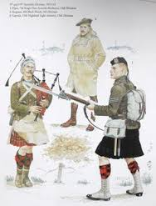
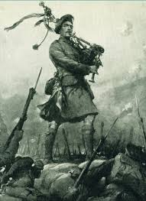
The reputation of the kilted regiments on the Western Front, such as the Black Watch, Queen’s Own Cameron Highlanders, Gordon Highlanders, Argyll and Sutherland Highlanders, led by their pipers gave them their nickname by the Germans, the ‘ladies from hell’.

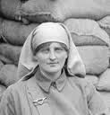
Individual heroism can be shown by the courage of one piper at the Battle of Loos where Piper Laidlaw won the V.C. This battle was fought in 1915 and became known as a Scottish battle with every Scottish Regiment represented. Haig was aware of the unfavourable ground and used gas for the first time to help cloak the advance. Despite serious casualties the Scots took their main objective but the reserves were kept too far back and the chance was lost. The Battle cost 20,598 killed with one third being Scottish. Scots fought in all the major actions on the Western Front and the Army as a whole was led by Sir Douglas Haig, A Scot.

It was not just Scotsmen who contributed to the Scots military effort on the Western Front Nurses such as Mairi Chisholm served in forward casualty clearing stations and in the medical services.

Source A: from a letter sent by Sir Douglas Haig, Earl of Bemersyde, in 1922 which was read at the memorial to the 16th (Service) Battalion Royal Scots.

To all ranks of the Army I commanded, I owe a debt which I can never sufficiently acknowledge. Yet, as a Scotsman, I need to honour the huge contribution made by Scots in the war. I have a special sympathy for those who mourn our countless thousands of Scottish dead. I am grateful for this opportunity to express my thanks to the officers and men of the gallant battalion that Sir George McCrae so loyally helped to raise
in 1914. As the commander of our Army in its first great offensive battle (the Somme), I can pay a special tribute to this Scottish regiment, which on 1st July 1916 suffered such heavy loss and served its country so well. The thought that Scotsmen served our country truly and well offers some consolation for the loss of our comrades and friends.

How fully does Source A explain the contribution of Scots to the military effort on the
Western Front?
Use the source and recalled knowledge. 9

