Growth of Radical Politics

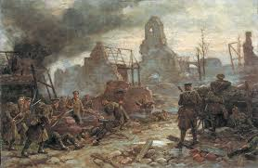
Information

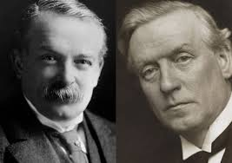
As the First World War progressed the Liberals collapsed as an effective electoral force. By 1915 the Liberal government was blamed for being incompetent in its handling of the war with problems surfacing such as the shell crisis and the ineffective Gallipoli campaign.
This led to arguments within the party, weakened its organisation and demoralised party workers. As a result of this party funds collapsed as members stopped paying subscriptions. By 1916,this led to a split between Asquith's independent Liberals and Lloyd George's coalition Liberals.

Among the working classes the Labour party was most likely to benefit from Liberal misfortunes. Their organisation was extremely effective with a focus constantly on local issues such as housing, rents and jobs which caught the interest of the new voters given the vote in 1918. Both the ILP and the Labour party continued to campaign for reforms in housing and health after the war and their focus on local issues was a big reason for Labour's success in the 1920s.
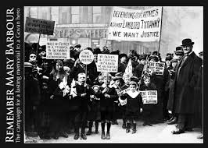
Issues such as the rent strike had increased the prestige and influence of ILP and improved the credibility of the labour movement. They were the party instrumental in orchestrating and organising demonstrations and supported workers grievances over prices and rents.
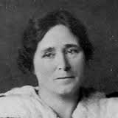
Many working class women had become politicised by their war work and the rent strikes. Women, such as Mary Barbour, Agnes Dollan and Helen Crawfurd became role models for women keen to make their voice heard politically for the first time and they tended to be Labour supporters.

Dilution of Labour
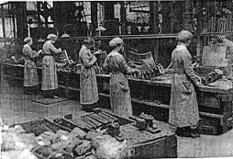
The Liberal government was blamed by working class for introducing dilution, passing legislation to regulate work practices, arresting strike leaders and initially supporting landlords when they raised rents. During the war production techniques had to be improved and the privileges of the skilled working class had been diluted to ensure maximum efficiency.

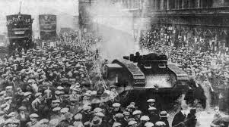
Red Clydeside
The effect of political developments such as the ILP and Red Clydeside also helped Labour.
The Clyde Workers Committee (CWC) was formed to control and organise action for an extension of workers' control over industry. Papers like “Forward” and “Worker” were suppressed by the Government.
The influence of John MacLean, Willie Gallacher, Jimmy Maxton, John Muir, Tom Bell and Jock Smith reached out to many working class men at the time. MacLean won the support of thousands of people with his socialist and anti-war views.
There was a Forty Hours Strike and demonstration at George Square which included the waving of red flags and riots which brought out troops and tanks on to the streets of Glasgow.

1918 Voting Act
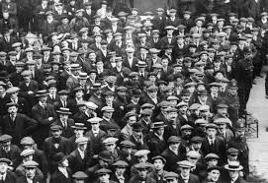
Effect of franchise reform in 1918 almost trebled the size of the electorate from 779,000 in 1910 to 2,205,000 in 1918. By giving the vote to men on the basis of age then almost inevitably the new voters would come from the poorer sections of society and would be more likely to vote for the working class party representing their best interests – the Labour Party. Not only had working class been given the vote. There was also an extension of the franchise to women over 30.
Catholic Irish vote deserted the Liberals and moved towards the Labour Party.

Results
In 1922 Labour won 29 seats in Scotland (10 in Glasgow) and then in 1924 they won 34 seats but saw this fall to 26 seats in second election in 1924. However, in the same election the Liberals had fallen to 9 seats in Scotland. By the end of 1924 the Liberals had only 8 MPs in Scotland.
Question

Source E: from T. M Devine, The Scottish Nation 1700–2007 (2006).

The emergence of Red Clydeside and the Labour breakthrough was only one part of the realignment of Scottish politics after the war. The most decisive feature was the complete collapse of Liberalism as an effective electoral force. At the end of 1916 Lloyd George had split the party and by the election of 1918 Liberalism was in disarray. Among the working classes the Labour Party was most likely to benefit from Liberal misfortunes. The Rent Strike had greatly increased the prestige and influence of the ILP. While the Liberal government denounced strikers as unpatriotic, the ILP supported the workers’ grievances over prices and rents. Labour also excelled in organisation. The focus was constantly on local issues of housing, rents and jobs. Labour gained the lion’s share of the new post 1918 electorate. The reward came in 1924 when Labour became the biggest party in Scotland, sending 29 MPs to parliament.

How fully does Source E explain the reasons for the growth of radicalism in politics in Scotland?
Use the source and recalled knowledge. (9)

Marking Scheme

The candidate makes a judgement on how fully Source E explains reasons for the growth of
radicalism in politics in Scotland in terms of:

Points from the source which show the candidate has interpreted the significant views:

The most decisive feature was the collapse of Liberalism as an effective electoral force.... Among the working classes the Labour party was most likely to benefit from Liberal misfortunes.
The rent strike had increased the prestige and influence of ILP.
Labour also excelled in organisation.
The focus was constantly on local issues.
Labour gained the lion‟s share of the new post 1918 electorate.

Points from recall which support those in the source:

Liberal Party split between Asquith's independent Liberals and Lloyd George's coalition
Liberals.
The Liberal government was blamed for being incompetent in its handling of the war.
Liberal government blamed by working class for introducing dilution, passing legislation to regulate work practices, arresting strike leaders and initially supporting landlords when they raised rents.
Arguments within the party weakened its organisation and demoralised party workers.
Party funds collapsed as members stopped paying subscriptions.
Coupon Election.
By 1924 the Liberals had only 8 MPs in Scotland.
The Rent Strike did much to improve the credibility of the labour movement.
Independent Labour Party instrumental in orchestrating and organising demonstrations.
ILP supported workers grievances over prices and rents.
Focus (of Labour party) was constantly on local issues of housing, rents and jobs.
Both the ILP and the Labour party campaigned for reforms in housing and health after the war and their focus on local issues was a big reason for Labour's success in the 1920s.
Effect of franchise reform of 1918 which almost trebled the size of the electorate from 779,000 in 1910 to 2,205,000 in 1918.
By giving the vote to men on the basis of age then almost inevitably the new voters would come from the poorer sections of society and would be more likely to vote for the working class party representing their best interests – the Labour Party.

Points from Recall which offer a wider contextualisation such as:

Catholic Irish vote deserted the Liberals and moved towards the Labour Party.
Extension of the franchise to women.
Many working class women had become politicised by their war work and the rent strikes.
Women, such as Mary Barbour, Agnes Dollan and Helen Crawfurd became role models for women keen to make their voice heard politically for the first time.
The effect of political developments such as the ILP and Red Clydeside.
The Clyde Workers Committee (CWC) was formed to control and organise action for an extension of workers' control over industry.
Papers like “Forward” and “Worker” suppressed.
Influence of John MacLean, Willie Gallacher, Jimmy Maxton, John Muir, Tom Bell and Jock Smith.
MacLean won the support of thousands of people with his socialist and anti-war views. -
Forty Hours Strike and demonstration at George Square, waving of red flag, riot, troops and tanks appear on streets of Glasgow.
In 1922 Labour won 29 seats in Scotland (10 in Glasgow) and then in 1924 they won 34 seats but saw this fall to 26 seats in second election in 1924 but in the same election the Liberals had fallen to 9 seats in Scotland.

