Evaluate how Useful – Scots on the Western Front

Extra information for Higher

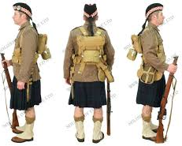
The source is taken from an account of the Battle of Loos in which Scots contributed vastly. This may have been because of the military tradition of Scots where the kilted regiments were considered to be good soldiers and frequently used as shock troops. Indeed it deserves to be called a Scottish battle owing to the large number of Scottish troops in action. 30,000 took part in the attack. One third of British casualties were Scottish at Loos. It was also the first taste of action for Kitchener‟s New Army volunteers.
The 9th and 15th Scottish Divisions were to be involved in the attack.

The source tells us that the soldiers experienced fear of injury –“My God, I‟m done for”, as well as a feeling of camaraderie – “he lifted his wounded pal‟s kilt then gave a laugh.” This was clearly happening in a combat situation as the source states that “machine guns were raking the street and bayonet fighting was going on”. However we should be wary as to whether the bayonets were being used in hand-to-hand fighting or were the soldiers dealing with prisoners?
However this was the only battle that Scots fought in. in the Battle of the Somme three of the divisions were Scottish. The 9th, 15th[Scottish] and 51st [Highland] took part as well as numerous Scottish battalions in other units such as the Scots Guards in the Household Division. 51 Scottish infantry battalions took part in the Somme offensive at some time, as well as Scots in the Royal Artillery or Royal Engineers which are not raised on a regional basis.
The Battle of Arras saw a concentration of 44 Scottish battalions and 7 Scottish named
Canadian battalions, attacking on the first day, making it the largest concentration of
Scots ever to have fought together. One third of British casualties were Scottish at Arras.
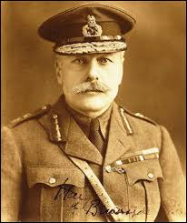
They were also in action at all of the major battles on the Western Front, such as Cambrai and Third Ypres.

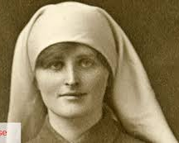
The normal life of Scots on the Western Front is not commented on in the source. The experience of Scots in Trenches led to problems such as trench foot. Rats, lice, especially for Scots wearing kilts , were a major problem as was mud, poor food and tiredness. As with other troops this led to shellshock and appalling wounds for many Scots as a result of artillery fire sniping and general attrition.
As the question is about Scots on the Western Front, the contribution of nurses such as Mairi Chisholm need to be remembered. It should also be noted that the Commander of the whole British Army throughout most of the war was a Scot; Sir Douglas Haig.

Source A: from the diary of Private Thomas McCall, Cameron Highlanders describing the attack at Loos, September, 1915.
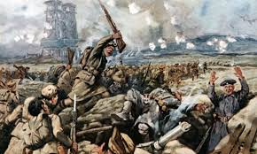
The soldier lying next to me gave a shout, saying, “My God! I’m done for”. His mate next to him asked where he was shot. He drew himself back and lifted his wounded pal’s kilt, then gave a laugh, saying, “Jock, ye’ll no die. Yer only shot through the fleshy part of the leg!” We moved on towards the village of Loos, where machine guns were raking the streets and bayonet-fighting was going on with Jerry (slang for Germans). Prisoners were being marshalled in batches to be sent under guard down the line. I came to a little restaurant. By the noise going on inside I thought they were killing pigs. I went inside and opened a door where blood was running out from underneath. I saw some Highlanders busy, having it out with Jerry with the bayonet

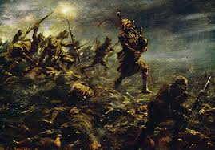
How useful is Source A as evidence of the experience of Scots on the Western Front?
In reaching a conclusion you should refer to:
• the origin and possible purpose of the source;
• the content of the source;
• recalled knowledge. 6

Marking Scheme

The candidate makes a judgement as to how useful Source A is as evidence of the
experience of Scots on the Western Front in terms of:

Origin:
By Private Thomas McCall who fought in the assault at the Battle of Loos with the
Cameron Highlanders.
Useful as source is personal eyewitness account of the battle that became known as “the Scottish battle‟.
The source also seems to be uncensored given the gory nature of content.

Possible Purpose:
It was a record of what had occurred at the assault on Loos by a soldier of the Cameron
Highlanders.
Model Answer

Source A is useful as evidence of the experience of Scots on the Western Front because it is a contemporary account of one particular Scottish man’s experiences written by Private Thomas McCall of the Cameron Highlanders describing the attack at Loos. He was a private in a Scottish infantry regiment which means that he would have been in the front line risking his life, but would not have been in a position to make decisions to change his circumstances. He was an eye witness at the battle and his views would have been typical of many infantry soldiers at the time. The purpose of this source was to record his feelings about the battle of Loos. The source mentions several typical experiences of Scots at this battle, which adds to its usefulness. For example, Private McCall mentions that his friend was wounded, showing the fear of many soldiers about their chances of survival when it states “The soldier lying next to me gave a shout, saying, “My God! I’m done for”. It also comments on the friendship in evidence between soldiers when his friend helps and reassures him.
However, the source does not mention that many other Scots had different experiences on the Western Front. Although Douglas Haig’s life was not in danger, he was responsible for making the decisions about the whole British Army as he was in charge. Nurse Mairi Chisholm also had a different experience of the war as she was a nurse in the front line. Finally the source itself only talks about one battle, early in the war and does not comment on the dangers which happened later on in the war or the conditions endured in the trenches while waiting for battles to happen.

