Essay Writing Nat 5 Exam

This type of question requires you to make a judgement about the extent to which a particular factor contributed to an event or development. You are required to give a balanced answer after making a judgement about the relative importance of other relevant factors and come to a reasoned conclusion based on the evidence presented.

The essay question will always start “To what extent was the issue affected by factor A”.
This means that you will always have 1 factor provided. You need to add the other factors that affected the issue from your own knowledge.
The essay questions are worth 8 marks and the marks can be awarded as follows:-
A maximum of 5 marks can be given for relevant, factual, key points of knowledge used to support factors, with 1 mark given for each point. If only 1 factor is presented a maximum of 3 marks should be given for relevant points of knowledge.

A further 3 marks can be given for providing the answer in a structured way and coming to a reasoned conclusion. This means that you have made a judgement about the factor in the question and then balanced this with a judgement about the importance of other factors.
1 mark will be given for your conclusion and overall judgement and 1 mark for providing a reason to support your answer.

Question: To what extent was the Orthodox Church important in keeping the Tsar in power before 1905? 8

Look at these 2 answers and mark them.

Answer A

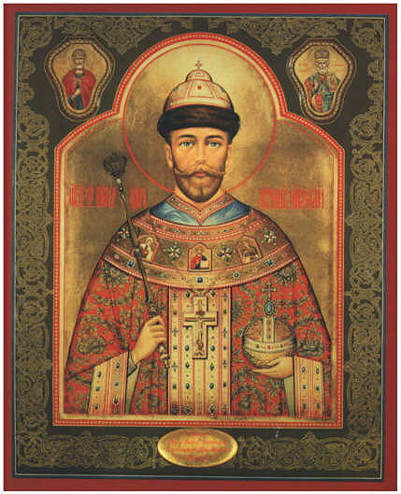
The church was important in keeping the Tsar in power as they brainwashed people into believing the Tsar was appointed by God.

However, there were other reasons which played a part in keeping the Tsar in power. The Tsar was kept in power by the Okrana which spied on people and made it difficult to organise protests. This frightened people from complaining. The Army was also important as it attacked people if the protested about the Tsar’s rule.

In conclusion, the church was important in keeping the Tsar in power.

Answer B

It is believed that the church was important in keeping the Tsar in power. Their ability to persuade the people that the Tsar was appointed by God and that is was a sin as well as a crime would have been important to the religious peasants in Russia.
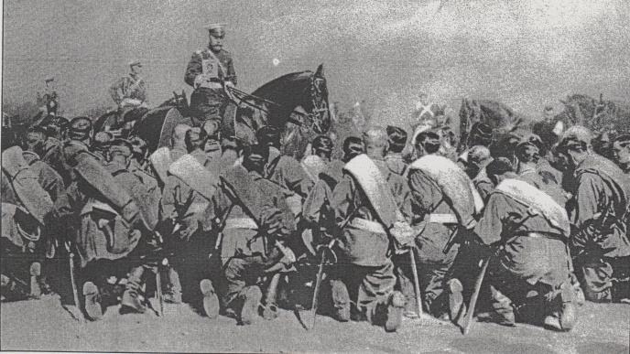
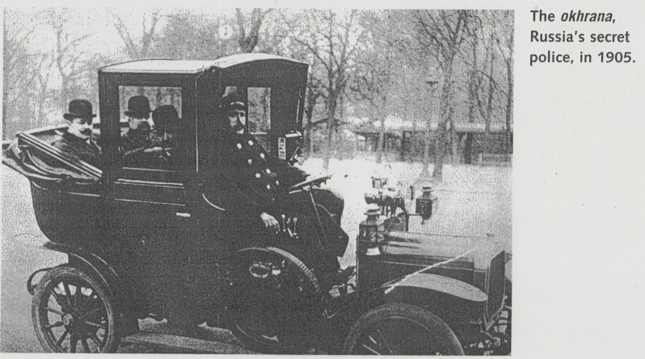
However, there were other reasons why the Tsar was able to stay in power. An important reason was the Okrana who spied on people and made it difficult to organise protests against the Tsar’s rule. Furthermore, the Army was important in physically attacking any protesters who made it to the streets. Lastly, the policy of Russification was set up to persuade conquered people would forget their old customs and nationality and agree that the Tsar, as ruler of Russia was their rightful monarch.

Overall the church was an important supporter of the Tsar. It persuaded people that the Tsar was truly appointed by God and that it would be a sin to oppose him.

Model Answer

The Church was important in keeping the Tsar in power as they told the people it was a sin as well as a crime to oppose the Tsar. However, the Okrana, the Army and the policy of Russification were also important.
Introduction which makes a judgement on the given factor and mentions the other factors which were involved.

The church was important as they made sure the peasants were aware of the Fundamental Law and that they were brainwashed into the belief that the Tsar was appointed by God therefore it would be wrong to disagree with him. However this was not his only support.
Paragraph which identifies and explains the reason the given factor was important in keeping the Tsar in power and gives a link to the next factor.

The Okrana, a part of the Civil Service, spied upon people who might disagree with the Tsar. They did not have to prove a case but could have people exiled to Siberia on the suspicion on a possible future crime. This made people scared to talk about protest and made it difficult to organise. Furthermore, the Army was organised more as an internal police force rather than a force to protect the country. This meant that in the final analysis, should anyone finally decide to protest on the streets the army was there to bully or kill them to stop any protest.
Paragraph which gives 2 factors. This gives the reasons why these factors helped keep the Tsar in power
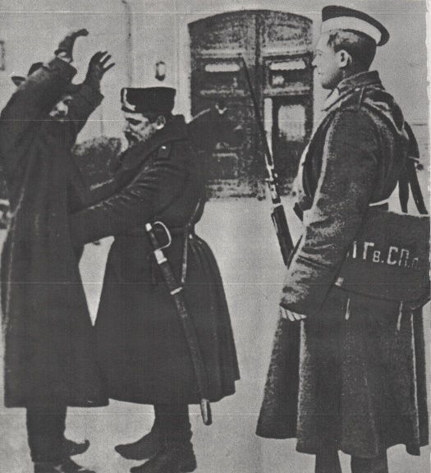
The policy of Russification helped to keep the Tsar in power by making people in the conquered territories think of themselves as Russian. They were banned from wearing their national dress, using their language in professional situations or worship in their own churches. This was intended to make them forget their own culture and accept the Russian Tsar as their rightful monarch.
Paragraph which identifies and explains the reason the given factor was important in keeping the Tsar in power and gives a link to the next factor.

Overall the church was important as it persuaded the people that the Tsar was appointed by God, but the Okrana was important in spying on people and making it difficult to organise protests. The policy of Russification was important in making people feel Russian. Finally the Army was important as it was the final force to smash any protests that made it to the street.
Conclusion which sums up the reasons for all the factors mentioned and gives a final judgement and a reason why you believe this was the main factor,

Comments about Answers A and B
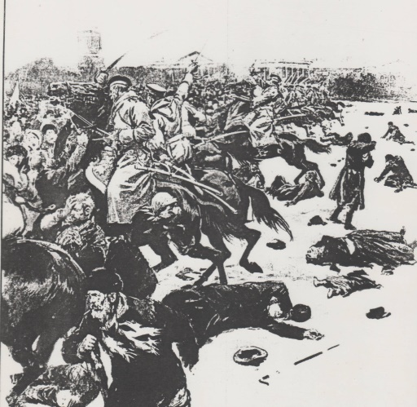
Answer A
The answer begins with a judgement about the extent which the church was important in keeping the Tsar in power. A brief point of knowledge (that they brainwashed people into believing the Tsar was appointed by God) is given in support of the judgement. The answer is structured (with the word However …..) and proceeds to provides 2 points of knowledge in support of other factors The answer ends with a conclusion but not a reasoned conclusion. In other words, no reason or explanation is given in support of the conclusion. This answer has both strengths and weaknesses. It provides a balance assessment of the factors which contributed to the maintenance of the Tsar’s power. However, there are not enough key points or knowledge given to gain 5 marks. This answer would instead gain 3 marks for knowledge. The answer is structured with a conclusion but no reason is provided in support of the conclusion. This answer would gain 2 marks out of 3 for structure. Overall this answer would gain 5 marks out of 8.
Answer B

This answer begins by making a judgement about the importance of the factor (the importance of the church in supporting the Tsar) identified in the question. Two points of knowledge are given in support of this judgement. The answer is then structured and balanced with a consideration of the importance of other factors. Three distinct relevant reasons are given to further explain the maintenance of the Tsar’s power. The answer concludes with an overall judgement and a reason is given to support this overall conclusion. This is a strong answer which would gain 5 marks for knowledge, 1 mark for providing a structured account, 1 mark for a conclusion and 1 mark for providing a reason in support of the conclusion. This answer would therefore be awarded the full 8 marks.

Questions

To what extent was patriotism the main reason that Scots volunteered to fight in World War One? 8

To what extent did the surveys of Booth and Rowntree cause the Liberal Reforms of
1906 – 1914? 8

