Economic Difficulties Post War

Extra Information for Higher

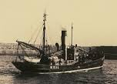
The source tells us that during the war the price of a barrel of herring had been the same throughout the war but, after an initial rise at the end of the war it began to go down. However, fuel, gear and wage costs had risen so much that the fishermen could not pay the gutters who then went on strike.
The source also notices that those involved in the fishing industry including fish merchants had lost markets in Germany and Russia during the war. This collapse of foreign markets for herring greatly affected the industry as European countries started to compete strongly with Scottish fleets and in 1920 the government removed the guaranteed price for the herring. The price of herring dropped dramatically and as a result it was no longer profitable. The result of was that for twenty years the industry went into a steep decline.

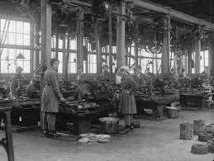
Fishing was not the only Scottish industry badly affected by the war. Agriculture suffered from competition after the war from cheap foreign imports of food like refrigerated meat from Argentina, frozen lamb and tinned fruit from Australia and New Zealand.

The Jute industry had thrived during the war as demand for sack cloth rose but after the war the industry faced direct competition from Calcutta in world markets. Price of goods collapsed resulting in mass unemployment, deep social misery and discontent especially in Dundee and several firms went into liquidation.
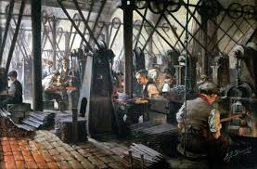

The Iron and Steel industries told a similar story. Demand for iron decreased during the war years as it was needed for the shipbuilding industry. But other countries increased their steel making during the war years and Scots manufacturers could not compete. As a result the iron and steel industries were severely affected by the downturn in demand from 1921 onwards.

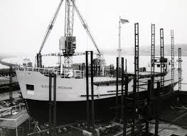
Again the Shipbuilding Industry suffered. The immediate impact of war on Clydeside shipyards was very positive and profits were good. However, after the war a return to competitive tendering along with the decline in the demand for steel and for ships, foreign competition, labour disputes and a shortage of manpower and materials all led to problems and shipbuilding went into decline.

Source D: from Following the Fishing accounts of Annie and James Watt who worked with the herring fishing fleets 1914–1920.

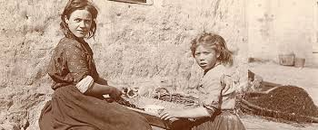
All the years that we worked, up till the end of the First World War, the price we got for a barrel of herring was 4 pence, this money was vital for many families. Thousands of barrels were shipped to Germany, Poland and Russia. Things were never as good with the herring after the war. The price went up to six pence for a time then they took it down to three pence. Costs had risen and the men couldn’t pay for the gear, the fuel and the wage. Things were that bad that they couldn’t pay us for gutting the herring so we went on strike.
One curer we worked for went broke. That was David Buchan. He was one of the richest curers in Peterhead. He’d a big house and everything, but he lost the lot. He’d plenty of money owed to him, but it was all in Germany or in Russia!

Evaluate the usefulness of Source D as evidence of the economic difficulties faced by Scotland after 1918? 6
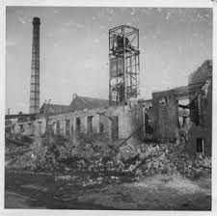
In reaching a conclusion you should refer to:
• the origin and possible purpose of the source;
• the content of the source;
• recalled knowledge.

