Democracy and Politics
Political Reasons
Changing political ideologies
Another motive for the growth of democracy was the change in political attitudes by those in power. By the middle of the 19th century political reform was no longer seen as a threat due to the birth of new ideologies such as Liberalism and democracy. Across the world struggles were taking place for liberty that Britain supported, therefore how could Britain argue against liberating their own country with reform? The American Civil War and its argument for individual freedom from slavery affected many artisans while Abraham Lincoln’s Gettysburg Address had a great influence on many of the people who read it.
Political Advantage
Political advantage was a huge factor in the extension of the Franchise as it effectively gave the party who granted suffrage to the lower classes the support of a significant percentage of the voting population and ensured their status as a major political force whilst also, as they thought, acting as a shield against the Socialist Labour Party and their growing popularity among the working classes. Therefore, it could be argued that the reform bill of 1867 was pushed through as a cynical, opportunist act.
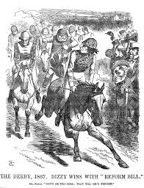
The Conservatives had been out of power for some 20 years and were keen to get back in. The death of Lord Palmerston in 1865 removed a, previously, immovable block to the idea of reform. After his death the Liberals split between those who wanted reform and those who did not. The Conservatives had to do something. If the Liberals sorted out their problems and pushed any sort of reform through, they could be out for a further 20 years. Disraeli, the conservative leader in the Commons believed that if his party could give the artisans the vote those men would be grateful and vote for his party. The Liberals did not sort out their problems and their government collapsed over how much reform to grant. Disraeli saw his chance and by 1867 the Conservatives were in power and were prepared to use the Liberal ideas of reform to maintain their hold on power. At the time it was stated that they “were stealing the Liberal’s clothes”.

The Attitude of the Liberal Party.
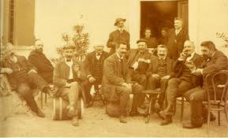
In Parliament it was widely accepted by the 1860s that reform was unavoidable. The issue now was the form that it would take. The Liberals recognised the changes taking place in society and from the 1850’s they argued for a widening of the franchise. They took their support from the property-owning Middle Class and they sought to extend this support by giving the vote to the skilled working class. They believed that the skilled workers were a “respectable elite” (Gladstone) who had a moral right to vote. They had proved their worth by their hard work, their membership of the church, their role in the Co-operative movement and the Friendly Societies and their desire for a higher standard of living. These skilled workers saved their money, valued education and read the popular penny press. Together with the Middle Class the skilled workers would be natural Liberal supporters and would ensure their political dominance in a reformed system.
While the skilled workers showed signs of taking on “liberal” values of thrift, independence and self-improvement there was no chance of the Liberals giving the vote to the unskilled masses who were regarded as little better than criminals. Such people were seen as immoral, corrupt, and irresponsible. The Liberals believed that splitting the skilled workers away from the unskilled and allying them to the Middle Class would create a stable society and would protect the Capitalist System which was being challenged by increasing Trade Union activity and industrial unrest.
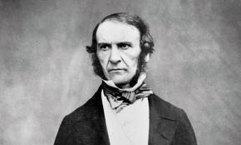
Lord Russell and a band of reforming Liberals introduced four bills in the period 1852-1860 for widening the franchise. They all failed. A new champion was to emerge in the formidable figure of William Ewart Gladstone, who believed in the moral right of people to be part of the constitutional arrangements of the country. The Liberal leader, Palmerston opposed all further reform and so Gladstone had to bide his time.
Gladstone was converted to the idea of reform by a combination of Radical and trade union pressure. He first revealed his change of mind publicity in the Commons in 1864 when he said, “Every man who is not incapacitated by some consideration of personal unfitness or political danger, is morally entitled to come within the pale of the constitution”.
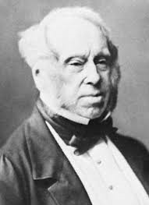
This angered his Prime Minister, Palmerston, who was still against reform and who retorted, “I entirely deny that every sane man has a moral right to a vote.” Gladstone’s approval of the Lancashire cotton workers’ political maturity led him to declare that it was “a shame and a scandal that bodies of men such as these should be excluded from the parliamentary franchise”.
The death of Palmerston in 1865 removed the most serious obstacle to reform in the Liberal party.

The Attitude of the Tories
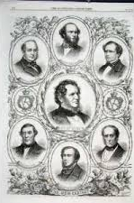
Nor were the Conservatives necessarily opposed to reform. Their leaders, Lord Derby and Benjamin Disraeli, feared that total opposition to all reform might exclude their party from power for very many years. They also entertained hopes that working class voters might prove to be on their side rather than on that of the Liberals. In 1865 the constituencies where working class voters formed a majority returned nine Conservative and five Liberals. Nor could they ignore the way that the over-representation of southern England had become more of a glaring abuse than ever. By 1865 a fifth of the electorate in England and Wales was returning half the MPs in the House of Commons. They accepted that pressure would eventually bring about further reform. Disraeli, their leader in the Commons, was even prepared to introduce limited reform of parliament himself, provided it didn’t go too far. His reasoning seems to have been that if further reform really was inevitable, as Bright kept telling everybody, then the Conservatives ought to jump in and take the credit for it. The death of Palmerston in 1865 cleared the way for reformers to lead the Liberals. Lord John Russell became Prime Minister, and Gladstone became the Chancellor in a short lived parliament.
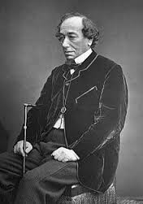
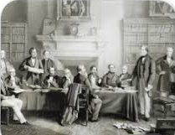
The incoming Conservative government hoped to move slowly and introduce some mild reform in 1868. However, public interest was now thoroughly aroused, and pressure built up for immediate action: Bright embarked on another speaking tour to campaign for reform; there was a short, sharp economic crisis which developed early in 1866, several companies went bankrupt and there was widespread unemployment. Bread was expensive following the poor harvest of 1865 and there was a sudden cholera epidemic which killed 8000 people in London alone. In July a demonstration was planned to take place in Hyde Park. When the Government closed the Park to the meeting there were some disturbances during which 1400 yards of railings were demolished. It was the combination of all these circumstances which influenced the new Tory Prime Minister, Lord Derby, into reluctantly introducing reform which would calm the situation down. Derby and Disraeli decided to make a bid for popularity which would prolong their stay in office and “dish the Liberals”.
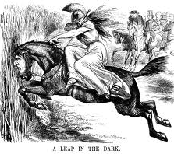
Both Disraeli and Derby were prepared to introduce a much more drastic bill than Gladstone’s if it would bring the Tories a long period in power. Their problem was that Cranborne and his supporters in the cabinet threatened to resign if the bill went too far, so in February 1867 a measure was introduced which was so mild that it caused uproar in the Commons when it was read out. It was obvious that the Liberals would not vote for it, and rather than be forced to resign, Disraeli decided to risk upsetting Cranborne by introducing a more radical measure. Cranborne and two other cabinet members resigned, but
Disraeli and the Liberals proposed several amendments, all accepted, which made the final bill even more extreme. This was very much seen as “a leap in the dark” and a risky venture but this Conservative bill became law in August 1867 and is usually known as The Second Reform Act.
Thus it was not the Liberals who brought in the second great Reform Act but the Tories. Disraeli stole their clothes by introducing a more radical bill than the one which Gladstone had introduced and been defeated on. He was concerned that reform should not transfer power away from the ruling classes and so he stressed the conservative nature of the changes in order to carry his own party with him. This has led some Historians to question Disraeli’s commitment to reform and to suggest it was an act of political opportunism.

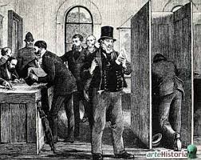
John Bright argued for a secret ballot to free working class, potential Liberal voters, from the fear of retaliation from bosses or landlords. This was granted in 1872.
It could be argued that the Corrupt and Illegal Practices Act of 1883, although appearing pragmatic might have been passed by the Liberals to limit the advantage of the richer Conservatives.

Redistribution of seats was more likely to happen under a Liberal Government as they wanted more city dwellers to vote as they tended to be Liberal. Equally they were concerned to take public attention away from foreign Affairs which was not a Liberal strong suite.

