Defence of the Realm Act
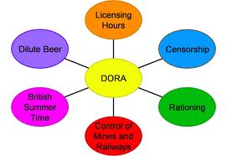
On 8th August 1914 the Government reversed 100 years of political advances and granted itself wide ranging emergency powers to control the British population during the war. The Defence of the Realm Act (DORA) of 1914 governed all lives in Britain during the First World War. The Defence of the Realm Act was added to as the war progressed and it listed everything that people were not allowed to do in time of war. As World War One evolved, so DORA evolved. They took over railways and docks under military law, employed special constables and could direct workers to where they were needed for the war effort. No-one was allowed to talk about naval or military matters in public places or to spread rumours about military matters. No-one was allowed to buy binoculars. They could not trespass on railway lines or bridges or melt down gold or silver. No-one was allowed to light bonfires or fireworks, give bread to horses, dogs or chickens or use invisible ink when writing abroad. No-one was allowed to buy brandy or whisky in a railway refreshment room or ring church bells.
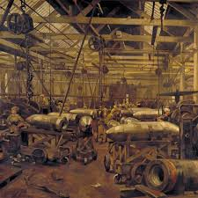
The government could take over any factory or workshop. They could try any civilian breaking these laws, take over any land it wanted to and could censor newspapers so that they could control what the public knew about the war.
As the war continued and evolved, the government introduced more acts to DORA.
The government introduced British Summer Time to give more daylight for extra work. Opening hours in pubs were cut, beer was watered down and customers in pubs were not allowed to buy a round of drinks. By the end of the war there were few facets of civilian life that DORA did not control.

As well as DORA the government introduced the Alien Registration Act in 1914. This meant that any foreign citizens had to register as aliens at their local police station. Restrictions were placed on where they could go and they could not change their address without telling the police. All these conditions were enforced with strict penalties.
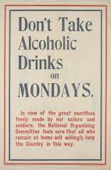
Anyone who criticised the Government was accused of undermining the war effort and being unpatriotic. Some people complained about the sheer pettiness of the Act but others were concerned that Britain’s liberal way of life was being compromised and that the amount of civil liberties being taken away were not really helping the war effort. There was a real fear that legitimate political debate was being stifled and that military courts should not be able to judge civilians.

Tasks
- List all the ways DORA interfered in British civilian life.

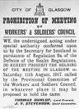
- Source A describes the activities of workers in Glasgow during the war.
The Government needed to control the factories to keep the soldiers supplied. However, the Clyde Workers Committee was formed to campaign against the Munitions Act, which forbade engineers from leaving the works where they were employed. On 25th March 1916, David Kirkwood and other members of the Clyde Workers Committee were arrested under the Defence of the Realm Act. The men were sentenced to be deported. The Committee’s journal, the Worker, was prosecuted for an article criticising the war. William Gallagher and John Muir, the editors, were both sent to prison.

How fully does Source A describe the effects of the Defence of the Realm Act on Scottish civilians?
(Use Source A and recall.) 5

Marking Scheme

From the Source:
Government needed to control the factories.
They could stop workers from leaving the company to work where they wanted.
They could arrest people who disagreed with the war.
They could censor and close down the Workers Committee paper.

Points missed out by the source.
The Government started British Summer time to allow more daylight hours for work.
They started Licencing laws to control drinking to make sure that alcohol did not interfere with work.
They controlled railways and docks under military law.
They started rationing to control food supplies.

