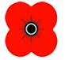
Commemoration of the War
The 11th November 1918, 11 o clock marked the end of the fighting in World War One. After 4 years the first casualty of the war was killed 2 miles away from where the last casualty died at two minutes to eleven.
This led to a strange set of emotions throughout Scotland; joy that it was over, pride in the effort the country had made and sadness at the cost of the war. Few families in Scotland escaped some loss. A father, brother son fiancée or sweetheart had been killed and the country felt a need to understand their loss and remember them.
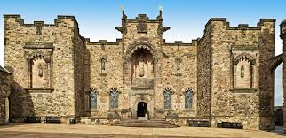
A British memorial was set up in London but Scotland felt that this was too impersonal and too far away. Scotland had suffered per capita the third worst casualties of any country in the war, only surpassed by Turkey and Serbia. Some 27% of all the Scots who fought in the war did not come back and this was 10% of all Scots men between 18 and 50 years old. When it is realised that statistically two men were maimed for every one killed the effect on the country was massive and Scotland felt the need for its own memorial
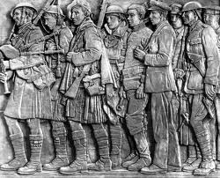
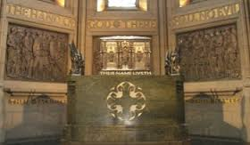
A committee was set up under the Earl of Atholl who stated that the Scottish Nation should put up a memorial “with their own hands and with their own money.”
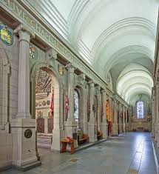
It was decided to build a “shrine” to the dead in Edinburgh Castle and this moving tribute to the servicemen covers Scotland’s impact on the war well. It is based on two arms with books showing the names of all the dead in bays dedicated to the regiments they fought with. Around the top of the wall there are the shields for each Scottish county that the soldiers came from. Below this is a frieze with the names of the major battles where they were killed. The centre is an arch with the shields of the major cities of Scotland. This arch leads to the centrepiece. A casket with the names of all the Scots killed, estimated at 150,000. Those who emigrated are not forgotten as Canada, Nova Scotia, New Zealand and Australia also have their shields displayed and finally a bas relief frieze surrounds the casket showing each type of unit that Scots fought with throughout the war.
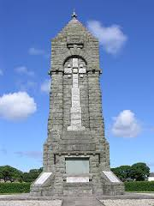
Although there was a National Memorial many local communities also felt the need to commemorate their dead.
Campbeltown has its own memorial which has some 750 names on it. This relates fairly closely to the national average of loss. In keeping with the family regiments and their recruiting areas, many of Campbeltown’s dead served with the 1/8th Argyll and Sutherland Highlanders. As a coastal town many also served with the Royal Navy.

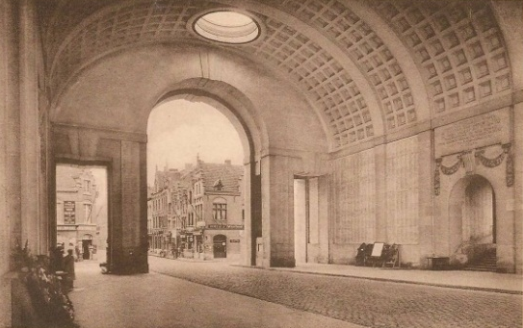
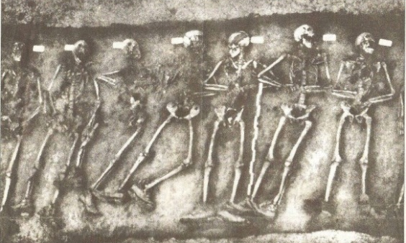
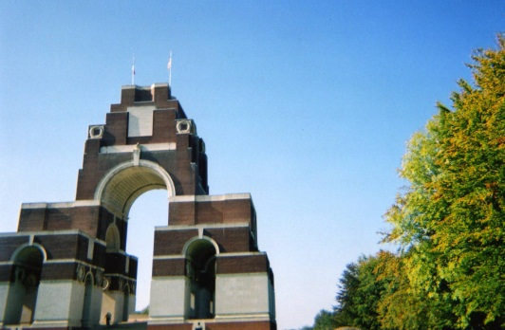
Scots are also commemorated on the western Front in both British and Scottish memorials. The Menin Gate and Thiepval Monument have the names, under their regiment, of men who were killed but who have no known grave.
Indeed, bodies are still being found in France today.

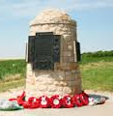
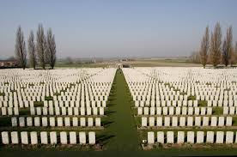
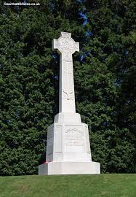
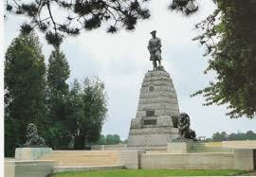
There are also Battalion and Divisional memorials as well as the grave yards which became a pilgrimage for so many Scots in the years after the war.
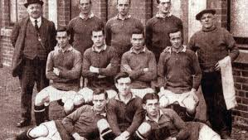
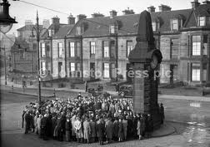
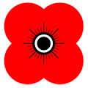
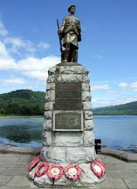
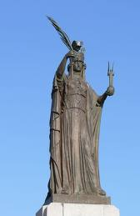

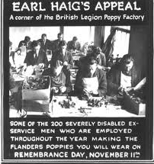
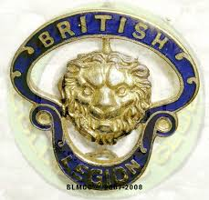
Finally, one of the best and most useful commemorations of the soldiers who served throughout the war came from the idea of their old commander who founded Earl Haig’s Poppy fund which collects money to help those who survived but who need help for various reasons. The founding of the British Legion is also important in keeping the memory of the sacrifice of so many Scots alive 100 years after the fighting finished.
Task
National 5
Describe the ways Scots commemorated their war dead in the years after World War One. 6
Higher
The year is 1922 – four years after the fighting has stopped. Your town is dedicating its new war memorial. How do you feel about the new memorial?
Explain your thoughts as if you were:
An ex-soldier who had volunteered in 1914
or
A widow whose husband and two sons were killed in the war
or
a member of the ILP who served time in prison as a conscientious objector.

