Changing attitudes to Working Classes

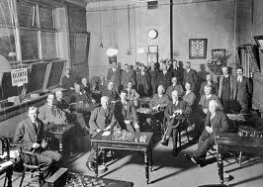
Another motive that is credited with being a factor that influenced the reforms and the extension of the Franchise was the changing attitudes of the upper classes toward the lower classes. The opinions of the upper classes towards the poor began to change progressively during the campaign for the extension of the franchise. It gradually became clear to the upper classes that the lower classes had become more respectable and better educated as can be shown by the skilled workers in Britain’s cities, known as “Artisans”. These people had attended night schools, taken active interests in local politics and had improved their living standards. This helped change the upper classes opinions showing them that the lower classes were good for more than simply working for them. A prime example of the lower classes impressing the wealthy was when they refused to work with cotton from Southern America, during the American civil war, as it had been produced by slave labour. Such actions convinced many politicians and upper class people that many of the lower classes where educationally and morally worthy of having the vote.

It became clear to Gladstone by 1884 (1884 Reform Act) rural voters had the same values, skills and morality as those in the towns and that they should be enfranchised on the same level, which in the process would appease the growing threat of socialism and Trade Unions.
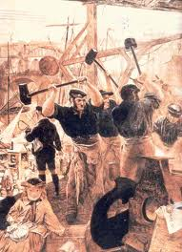
The changing attitudes of the upper classes towards the lower classes were an important development that obviously was a contributing factor in the extension of the franchise. The upper classes view of the lower classes was vital if they were to attain the vote as they were the people in the position to grant them suffrage. By the upper class changing their view that the lower classes were only fit for working, and recognising their qualities and morality they were able to acknowledge that these people were responsible enough to be given an influence in how the country was run.

