Battle of the Somme
The Battle of the Somme could be considered as a Scottish battle as 3 of the 4 full Scottish Divisions took part as well as many other Battalions attached to other divisions. In all 51 Scottish battalions served at the Battle of the Somme. Like the battle of Loos this was a battle which Haig believed was at the wrong time and in the wrong place. Again he was forced to attack to force the Germans to move troops from their major attack against the French at Verdun. The Germans were putting a lot of strain on the French Army and it was feared that they might break if they did not get relief.
Preparation:
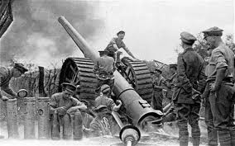
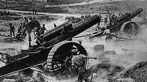
The preparation began with an 11 day long artillery bombardment, with pauses to trick the Germans into manning their front line trenches. Never before had the British artillery men had so much fire power with 1500 guns along a 30km front line and 1,738,000 shells ready to be fired at the German trenches. The logic behind this was that the artillery guns would destroy the German trenches; kill the soldiers, destroy their weapons and barbed wire placed in front of the trenches. The artillery bombardment began on 24th June. The Generals planned for the soldiers to go over the top on 29th June. However, the attack was delayed until 1st July due to bad weather.
British spotter planes would relay information about the position of German artillery to British gun crews on the ground so that they could target their fire accurately.
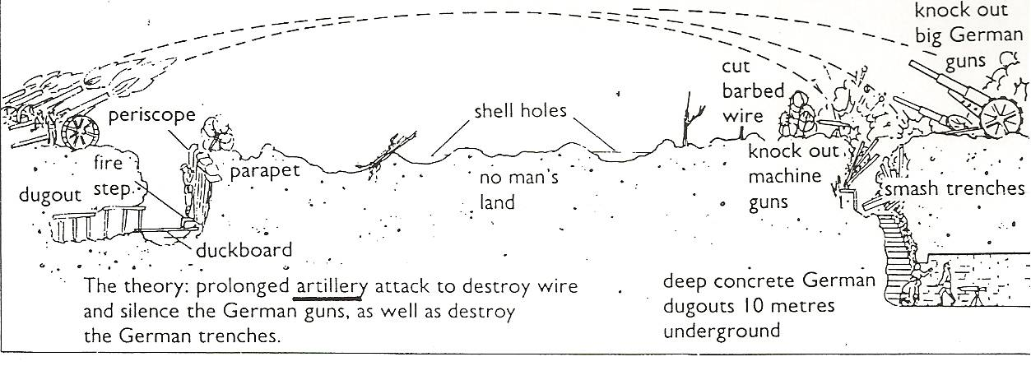
Haig then believed that the British soldiers could go over the top and stroll towards the enemy trenches as their weapons would be destroyed, and they would all be dead or ready to surrender. Haig felt this was necessary as his troops were not well enough trained.
1st July 1916
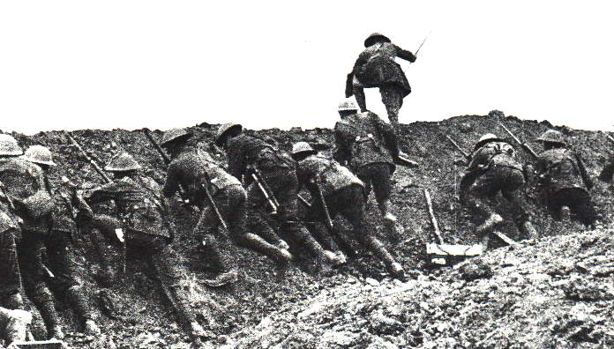
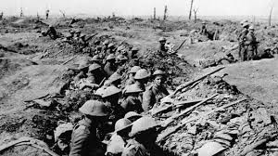
British troops were ordered to be ready to go over the top at 7.30am July 1st. The British wanted to go over the top at night in the dark, however the French wanted light for their artillery. The whistle blew at 7.30am and tens of thousands of men clambered up the assault ladders and into no man’s land.
They advanced at a steady pace so as to not become disorganised, carrying packs weighing 60lbs. One company Commander is said to have given each of his four platoons a football so they could compete to see which would be first to dribble the ball successfully across No Man’s Land.
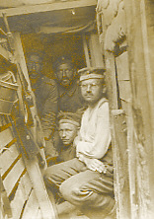
The British artillery bombardment was a complete failure as it had failed to crush enemy defences. The barbed wire had not been destroyed, the German machine guns had not been destroyed and not many German soldiers had been killed. In fact, the Germans had deep dugouts for their men and all they had to do when the bombardment started was to move these men into the relative safety of the deep dugouts. When the bombardment stopped, the Germans would have known that this would have been the signal for an infantry advance. They moved from the safety of their dugouts and manned their machine guns to face the British and French. This meant that the Germans were able to exploit their good defensive positions on higher ground.
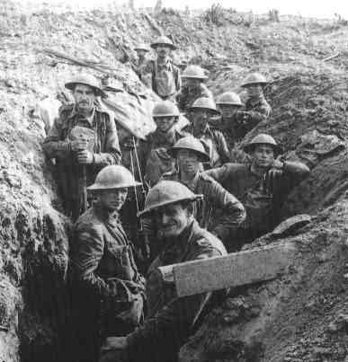
The first day of the battle of the Somme was the worst day in the history of the British Army. This was due to the fact that over 20,000 British soldiers were killed and almost 40,000 wounded. The Battle continued until November 1916. Since the 1st July, the British suffered 420,000 casualties. The French lost nearly 200,000 and it is estimated that German casualties were in the region of 500,000. Over 1 million men were killed or wounded at the Battle of the Somme.
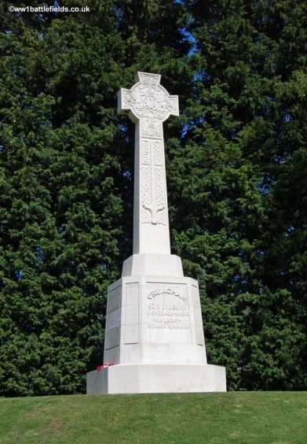
The rest of the battle.
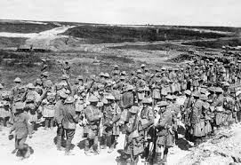
Most people now think of the Somme as a 1 day disaster but the battle raged till 13th November 1916 with the taking of Beaumont Hamel by the Scots, in an attack led by the 1/8th Argylls (South Kintyre) Battalion. There is also a pipe tune named over this event.
It was a very bloody affair for Campbeltown and, unusually, there is a Battalion memorial at Beaumont Hamel.
Haig changed his tactics from an attempt at a breakthrough to a battle of attrition, where it became more important to kill Germans than to take land. Although expensive in lives, it appeared to be borne out by the comments of German generals who referred to the battle as the “muddy grave of the German army”.
Tasks
- Why was the Battle of the Somme such an expensive battle in lives? 5
Source A is from Philip Gibbs, a journalist in 1916.
There were conflicting reports as to the artillery’s effectiveness and patrols sent out on the eve of the attack reported that the enemy front line was strongly held. Many of the rounds fired had been duds, while many others had been shrapnel which had little or no damaging effect on the enemy wire or trenches.
How fully does Source A describe the reasons why the first day of the Battle of the Somme failed? 5
- Source B is from Derek Young, a Lieutenant in the Seaforth Highlanders in “Scottish voices of the Great War”, 2005.
I blew my whistle loud and clear and we clambered over the parapet into the open facing the German lines about 3 – 400 yards in front. Immediately there was an appalling din and we advanced under a hail of thousands of bullets whizzing through the air from rifles and machine guns, and with high explosive shells exploding and throwing up earth and metal, just Hell broke loose.
Evaluate the usefulness of the above Source B in describing the British Infantry’s experience in the Battle of the Somme. (You may want to comment on who wrote it, when they wrote it, why they wrote it, what they say or what has been missed out.) 6

