Battle of Arras
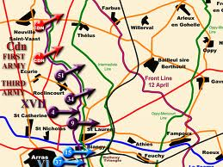
By 1917, the British Army had become a strong fighting force. In April 1917, they moved into the area round the French town of Arras. This area was chosen to help support a new French attack at Chemin des Dames. Scheduled to start a week earlier, it was hoped that the British attack would draw troops away from the French front. Led by Field Marshall Douglas Haig, the BEF began making elaborate preparations for the assault.
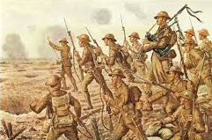
The battle which followed probably contained more Scots fighting in one place than at any point in the War. Ten Scottish Divisions fought at Arras with nearly one-third of the 159,000 casualties being Scots.
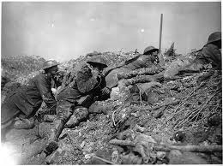
The Plans

This could be classed as a new type of attack using many of the lessons learnt in earlier battles. The parts of the army were much better coordinated with better communications between artillery, aircraft, tanks and infantry.
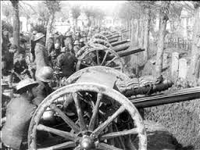
Haig intended to attack with 3 armies. The artillery was told to concentrate on specific areas rather than bombard the whole front. Shells cut the wire and gas shells killed German transport horses, which made moving guns impossible. A new idea was the construction of tunnels under no man’s land to move the 24,000 assault troops closer to the German lines secretly and safely as well as placing mines under the German trenches. When the troops attacked in the open creeping barrages were ordered just in front of them to keep the Germans heads down. They also improved their counter battery fire to destroy the German artillery.
On March 20, the preliminary bombardment of Vimy Ridge commenced. During the bombardment, British guns fired over 2,689,000 shells.
Troops used a new method of attack called “bite and hold”. Instead of all the soldiers attacking in waves across the whole front, one part would advance. It would then consolidate the ground it had captured. Another part of the army would then continue the attack and this was repeated over and over.
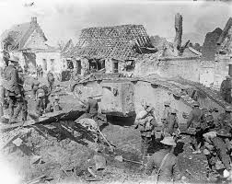
The Germans also changed their defensive tactics. They held the front lines with minimum strength with counterattack divisions kept close at hand in the rear to seal off any breaches.
The attack
On April 9 the assault moved forward. The British troops slowly moved behind the accurate creeping barrage towards the German lines. At Vimy Ridge the Canadians achieved stunning success and quickly took their objectives. A breakthrough may have been achieved, however the attack plan called for a two-hour pause once objectives had been taken and darkness prevented the advance from continuing.
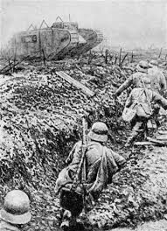
In the center, British troops attacked east from Arras. A key section of the German defenses in the area was taken on April 9th; however, it took several more days to completely clear the Germans from the trench system. The German new defensive system did not work as their reserve divisions were stationed 15 miles behind the lines, preventing them from rapidly advancing to block British attacks.
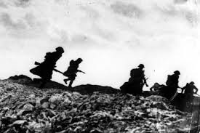
By the second day, German reserves were beginning to appear and slowed British progress. After this, a pause in the fighting occurred as both sides rushed in reinforcements to support the troops at the front. Over the first few days, the British had made dramatic gains including the capture of Vimy Ridge and advanced over three miles in some areas.
By April 15, the Germans had reinforced their lines and were prepared to launch counterattacks. The first of these failed after a determined attack by the Australian 1st Division. Fighting resumed on April 23, and the battle continued, turning into a grinding war of attrition as the Germans had brought reserves forward in all sectors and had strengthened their defenses.
Though losses were increasing rapidly, Haig was pressured to keep the attack going as the French offensive was failing badly. While fighting continued for a few more days, the offensive officially ended on May 23.

The Aftermath
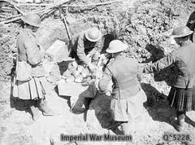
In the fighting around Arras, the British suffered 158,660 casualties while the Germans incurred between 130,000 to 160,000. The Battle of Arras is generally considered a British victory; however it did little to alter the strategic situation on the Western Front. Following the battle, the Germans built new defensive positions and a stalemate resumed. The gains made by the British on the first day were astounding by Western Front standards, but an inability to swiftly follow up prevented a decisive breakthrough. Despite this, the Battle of Arras taught the British key lessons regarding the coordination of infantry, artillery, and tanks which would be put to good use during the fighting in 1918.
Task
Write a paragraph to show how the Battle of Arras used the troops more effectively than the Battles of the Somme and Loos.
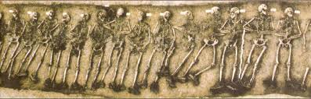
The bodies of a section of soldiers just found, some 90 years after the battle.
