Agriculture and the Fishing Industry
Before the war, farmers in Britain faced hard times as public demand for cheap food led to an increasing reliance on foreign imports. By 1914, Britain produced only 40 per cent of the food it consumed which was enough to last for only three days per week. The other days depended on imported meat from Argentina, mutton and dairy produce from Australia and New Zealand, and wheat from the USA and Canada. When war broke out these imports were threatened by Germany's U-Boat campaign which sought to starve Britain into submission.
As a result of this food became increasingly scarce and more expensive as the war progressed and so did the risk of discontent. By October 1915, when Germany called off her first U-boat, 900,000 tons of British shipping had been sunk. British production, therefore, became more important.
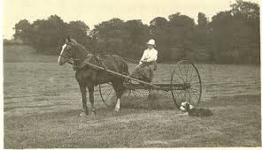
This led to more emphasis on what Britain could produce from its own farms. However they had their own problems as a result of the war. There were labour shortages as many men had volunteered to fight in the war. There were more men from this industry than any other. The number of farm workers dropped by 18,000 over the course of the war and the number of farm labourers fell from 107,000 to 89,000. Other men chose to move from the land for higher wages in munitions industry. If this was not enough the Army commandeered many of the horses for service in France and as they were the main motive power on the land this led to major problems. Also there was a shortage of fertilisers as the Army needed phosphates for making explosives.
However, the war years were good for farmers. Wages for labourers rose 150% and the average wage of a skilled ploughman or shepherd more than doubled by 1919. During the war years many farmers made money from rising demand for food and animals.
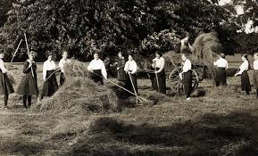
These problems were overcome by increasing use of machinery such as early tractors and the deployment of women, boys, older men and even prisoners of war and conscientious objectors. City girls volunteered for the Women’s Land Army which started in 1917: 33,000 women joined the 80,000 women already working on the land, often doing the same hard manual labour which the men had done. Some girls found that they enjoyed milking cows or ploughing with a horse. Machines introduced to replace horses taken for war effort and 2000 tractors were imported from the U.S.A. to speed up mechanisation.
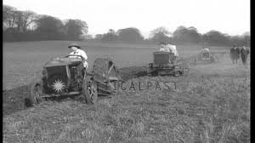
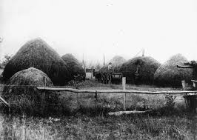
A great effort was also made to grow more food in Britain itself. All available and suitable land was ploughed up in order to plant wheat and corn, such as golf courses. Hillsides and public parks were ploughed up. Waste land round towns and cities was rented out in small sections to tenement dwellers as allotments, on the conditions that they grew food, usually vegetables, until the war ended.

A total of 7.5 million acres was added to cultivation by 1918. The output of cereals and potatoes went up by almost a half, though there was some decline in milk and meat because of the loss of grassland. The 1917 harvest was the biggest and best ever and the allotment campaign was a great success.

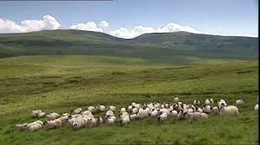
Attempt to grow more in Scotland were not very successful as amount of suitable land was limited; many were hill farms. Only 5 out of 19 million acres were under crops but the main contribution from farming in Scotland was from sheep farming: wool and meat which provided a good profit for farmers. The sheep industry enjoyed full employment and high wages from 1916, when the Government bought all of Scotland’s wool production to produce uniforms and army blankets and prices were 60% higher in 1918.
Farmers were encouraged to grow more by guaranteeing them high prices by the Corn Production Act, 1917 and Farm workers’

The government also passed the Corn Production Act 1917 which guaranteed high prices for home grown cereals such as wheat and oats and protected the wage of the farm labourer wages which were increased to a minimum of £1.25 a week. Farming became a reserved occupation and it was possible to claim exemption from Military Service if you were engaged in essential farm work. The production of wheat for bread, oats for horses and potatoes as a basic foodstuff for the people, rose very markedly between 1913 and 1918 and the trend of British farming which had been away from arable farming and towards pasture farming was reversed. Three million acres of grassland were ploughed up and large areas of pastureland were brought under the plough.

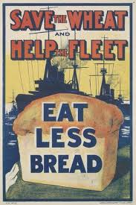
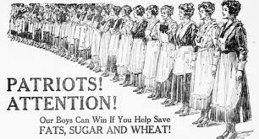
The government did not only try and increase the amount of food being produced in the country; they also tried to make sure it was used sparingly and more efficiently. They introduced a propaganda campaign and rationing. In 1917 the Germans restarted their unrestricted submarine warfare and food shortages became more serious as German submarines began targeting merchant ships bringing in food imports. Food shortages led to ‘meatless’ days by 1918: Wednesdays and Fridays in Scotland. This led to voluntary rationing which was not very effective. By January 1918 the Ministry of Food introduced compulsory rationing. Sugar was followed by butcher meat and full-scale rationing was in effect in Scotland by 7th April 1918.

Finally the government started convoys. This was a group of merchant ships or troopships travelling together with a naval escort. They reduced the number of ships sunk by U-Boats drastically.

Post War
After the war was over the government introduced the1920 Agricultural Act which was meant to maintain prices and production. However, by 1921 this Act was abandoned because of the poor state of the economy causing hardship for many farm workers who lost jobs or had wages cut.

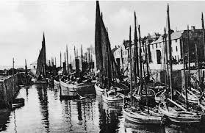
Fishing
The start of the 20th century was looked on as the glory days of fishing in Scotland. By 1913 10,000 Scottish herring boats were landing 25% of the UK total. Railways had opened up the home markets and the export market was strong. Fishing was a major industry before the First World War, employing over 32,500 men. However, by 1917, it was employing fewer than 22,000 men.

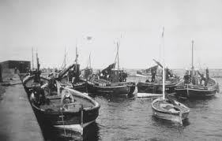
In September 1914 east coast ports in Scotland were taken over by admiralty and neutral fishing boats banned. The North Sea was almost totally closed to fishing. Fishing was only allowed in inshore areas on the West coast and banned completely in the Firth of Clyde. The loss of the herring trade to Russia and Northern Germany caused hardship and the white fish industry decimated with only the herring industry remaining stable. Restrictions on how much could be fished pushed up prices and by 1917 white fish was rationed. From 1917 onwards there was a slight improvement to the industry when the Germans started unrestricted submarine warfare.
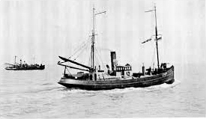
Fishing boats were chartered as minesweepers. The Royal Navy Reserve (Trawler Section), 8,000 strong, kept the industry going when restrictions elsewhere prevented its operation and their boats were used as minesweepers. 2,000 of these fishermen came from Lewis. Many of the Scottish fishermen and merchant navy sailors who lost their lives came from the Western Isles which led to a local perception that these areas suffered disproportionately.

By 1918 the fishing industry faced rising fuel costs and the need to repair and re-equip boats after war service combined with a lack of compensation. Although the fishing industry did recover after the war, revolution and post war changes in Eastern Europe meant that traditional export markets for herring in Germany, Eastern Europe and Russia were lost causing a slump.
Task
Source A is from Charles Davies, a Scot who lived in London during the war. In 1975 he was interviewed about his experiences during the First World War.
When I came back after the war my family told me how bad it had been. You see, us being an island hardly any food could get through, because German U Boats were sinking our food convoys. My family lived on bones from the butcher made into soups. And stale bread. When some food did get delivered to the shops everyone from miles around crowded round the place. The queues stretched for miles, and if you were old or unsteady on your feet you stood no chance. Many, especially children, died of starvation. Food riots were very common.
Source B is from the War Memoirs of David Lloyd George (1938).
So far as the vast bulk of the population was concerned, this rationing system ensured a regular and sufficient food supply; and it made it possible for those in charge to calculate with some precision how best they could make the stocks of available food stuffs go round fairly. Although there was a degree of scarcity, we were never faced with famine or actual privation. The steady improvement in our national health figures during and after the war shows that compulsory temperance in eating was in general more beneficial than harmful in its effects. Credit is due to our people for the loyal manner in which they submitted themselves to these strange and unwelcome restrictions. Without general goodwill it would have been impossible to make the regulations effective.
Compare Sources A and B about the supply of food during the Great War. 5
You should compare the content overall and in detail.

Here is a weak answer. Mark it and state why you think it is a weak answer.

The two sources are about food supply in the war.
One thinks the supply was bad. It says ”Food riots were very common.”. The other thinks it is good. It says “this rationing system ensured a regular and sufficient food supply.”

One said “Many, especially children, died of starvation.” And the other one says “Credit is due to our people for the loyal manner in which they submitted themselves to these strange and unwelcome restrictions.”
The sources are about food supply but they say different things.

Here is a much better example. Compare it to the first and say, in detail, why you think it is better.

Overall the sources are about food supply during the war. Source A believes food shortages caused big problems whereas Source B claims the food supplies were controlled and organised so everyone had enough to eat,

In detail Charlie Davies reports that hardly any food could get through whereas Lloyd George states that there was a regular and sufficient food supply.

Davies refers to the U Boat campaign which became more serious in 1917 when unrestricted submarine warfare began and all ships to Britain were targets. At that time the government introduced food rationing.

Davies claims the food shortages led to serious problems. “Many, especially children, died of starvation.” While Lloyd George states “we were never faced with famine or actual privation.” It’s possible that Davies is exaggerating as he only heard these stories when he came back from the war. On the other hand Lloyd George was Prime Minister so he would make the system sound as if it all worked well.

Davies claims that his family only lived on ”bones from the butcher made into soups. And stale bread.” Lloyd George states “compulsory temperance in eating was in general more beneficial than harmful in its effects.” Rationing was an attempt to make sure that people got fair shares. As food became scarcer prices began to rise. Food rationing stopped some people having too much food but made sure everyone had enough.

Davies also says that “When some food did get delivered to the shops everyone from miles around crowded round the place.” Photographs of the time do show long queues. Lloyd George says “the rationing system ensured a regular food supply.” That was also true. Some rationed food was scarcer so people had to queue when supplies did eventually arrive.

Finally Davies claims “Food riots were very common” whereas Lloyd George says “Without general goodwill it would have been impossible to make the regulations effective.” Overall food rationing made sure everyone got a fair share of food rather than using the black market and paying high prices.

Both sources may not be entirely accurate. Charlie Davies was reporting stories he had been told which might have been exaggerated. Lloyd George is writing his memoirs which are always meant to make the politician look good so naturally rationing is described as a success.

